Contents
Contents

Introduction 003
Role-plays
Teaching notes 004
Las redes sociales y la tecnología 005
La música 008
El deporte 012
Donde vivo 015
En el restaurante 019
La salud 021
Las vacaciones 025
Los estudios y el trabajo 028
Answers 031
Photo cards
Teaching notes 035
Los amigos y la familia 037
El matrimonio y la vida en pareja 042
Las redes sociales y la tecnología 046
Las tradiciones y las celebraciones 051
Las obras caritativas y el voluntariado 055
Los problemas medioambientales 059
La pobreza y los sin techo 064
El trabajo y elegir profesión 067
Answers 073
General conversation
Teaching notes 076
Asking questions 077
Key ingredients 083
Practice questions 094
Answers 100
Revision
Teaching notes 102
Mind-map template 103
Word sort 104
Inference grids 105
Pass the parcel speaking 109
Answers 112

Introduction
Introduction
This GCSE pack is designed to prepare students for their Spanish speaking exam.
The pack has been devised for use with the AQA, Edexcel and WJEC Eduqas specifications for GCSE Spanish. The activities and ideas will help students develop confidence in preparing for the three elements of the exam: the role-play, the photo card and the general conversation.
The pack contains worksheets, pair work speaking activities, games and practice exam questions along with revision materials. You’ll find teaching notes at the start of each section and answers at the end of each section.
Our thanks go to our contributing writers: Nick Richards-Gourves, Barbara Gerard and Lorraine Lateu.

Role-plays
Role-plays

Teaching notes
This section of the pack consists of eight role-play resources on eight different topics:
- Las redes sociales y la tecnología
- La música
- El deporte
- Donde vivo
- En el restaurante
- La salud
- Las vacaciones
- Los estudios y el trabajo
- The resources include worksheet activities to revise key topic vocabulary and phrases.
- These activities are designed to support students with the pair work role-play practice.
- Foundation and Higher role-play exam-style tasks are also provided for teacher assessment purposes.
- Answers are provided at the end of the role-play section, on pp.31-34.

Las redes sociales y la tecnología

Translate these key words and phrases into English.
- una red social
- un ordenador portátil
- un foro de discusión
- hacer amigos
- comunicar
- un teléfono móvil
- un mensaje de texto
- compartir fotos
- en línea
- robo de identidad
- la intimidación
- anónimo

Add the correct question words from the box and complete the translations.
Dónde | Por qué | Cuál | Qué
Cuánto | Qué | Cuáles | Cuándo
  - ¿ haces en Internet?
What ?
  - ¿ es tu red social preferida?
Which ?
  - ¿ estas en línea?
When ?
  - ¿ utilizas tu teléfono móvil?
Where ?
  - ¿ hiciste en Internet la semana pasada?
What ?

  - ¿ a los jóvenes les gustan las redes sociales?
Why ?

  - ¿ tiempo pasas en línea?
How much ?

  - ¿ son los peligros de las redes sociales?
What (which) ?

Match all the possible answers to the questions from task B – there may be more than one option.
- Es fácil intimidar a otros y además es anónimo. |  | - Utilizo el teléfono cuando salgo con mis amigos. Es importante para sentirse seguro.
- Yo paso todo mi tiempo en Internet. |  | - Estoy en internet por la tarde, para hacer los deberes.
- La que yo prefiero es Instagram porque puedo compartir fotos. |  | - Escucho el álbum nuevo de mi cantante preferido.
- Yo prefiero Twitter porque mis famosos preferidos lo utilizan. |  | - En mi opinión, es popular entre los jóvenes porque a ellos les gusta hacer amigos en línea.
- Normalmente, juego a juegos en línea como, por ejemplo, World of Warcraft. |  | - Paso generalmente cuatro horas al día en Internet.
- Utilizo mi ordenador portátil en todas partes: en el instituto, en el centro comercial, en la casa.

1 = | 2 = | 3 = | 4 = | 5 = | 6 = | 7 = | 8 =

Role-play practice
Instructions
Work with a partner and decide who will be A and who will be B.
Prepare the prompts for card A or B below, making sure you cover up your partner’s prompts so that you don’t look at the unprepared question in advance.
- You should address each other as ‘tú’.
- When you see this - ! - you will have to respond to something you have not prepared.
- When you see this - ? - you will have to ask a question.
- When you are ready, practise acting out the role-play.
- Partner A will speak first. Take it in turns to say one thing (one bullet point) at a time.

- You are discussing online activities with a friend via Skype.  Prepare the following questions and responses. You will speak first.  - ? favourite social network  - your favourite social network  - social networks – one advantage  - ! answer an unprepared question  - activities online last weekend |  | - You are discussing online activities with a friend via Skype.  Prepare the following questions and responses.  - ! answer an unprepared question  - social networks – one disadvantage  - ? when online  - ? last weekend online  - activities online next weekend.

La música

Look at the example role-play card and complete the mind-map.
Role-play task
- You should address your friend as ‘tú’.
- When you see this - ! - you will have to respond to something you have not prepared.
- When you see this - ? - you will have to ask a question.
Estás hablando de música con tu amigo español.
- la música que tu escuchas – dos detalles
- ? opinión
- una fiesta del fin de semana pasado
- la música – una ventaja
- !

Role-play mind-map
- Note useful verbs, nouns, adjectives and question words for this role-play card.
- Try to predict what you could be asked for the unprepared question.
- Compare and share your ideas with a partner or small group.
la música que tú escuchas |  | La música |  | una fiesta del fin de semana pasado
? opinión |  | ! |  | la música – una ventaja

Match up these useful verbs.
- Escucho |  | - It is
- Fui |  | - Do you like
- Es |  | - I danced
- Bailé |  | - I listen
- Escuchas |  | - Do you listen
- Te gusta |  | - I went

1 = | 2 = | 3 = | 4 = | 5 = | 6 =

Translate the following possible answers into Spanish. You have been given the first letter of each Spanish word to help you.
- I listen to music in my room in the evening. Y e m e m h p l t

- I like pop music because it’s cool. M g l m p p e g

- I like listening to music. Do you? M g e m. Y a t

- Do you like listening to music? T g e m

- I danced with my friends. Y b c m a

- I went to a party with my friends. Y f a u f c m a

- Music relaxes me. L m m r

- It’s entertaining. E e

Coping with unprepared questions.
Use or adapt key words in the question to write your own answers. Look at the example.
¿Quién es tu cantante preferido? Mi cantante preferido es Ed Sheeran.
- ¿Tocas algun instrumento?

- ¿Cuál es tu estilo de música preferido?

- ¿Te gusta la música española?

- ¿Has ido ya a un concierto?

Now go back and practise the role-play task from exercise A with a partner, adapting all these ideas.

Exam practice tasks
Foundation assessment role-play  Instructions  - Your teacher will play the part of your Spanish friend and will speak first.  - You should address your friend as ‘tú’.  - When you see this - ! - you will have to respond to something you have not prepared.  - When you see this - ? - you will have to ask a question. | Higher assessment role-play  Instructions  - Your teacher will play the part of your Spanish friend and will speak first.  - You should address your friend as ‘tú’.  - When you see this - ! - you will have to respond to something you have not prepared.  - When you see this - ? - you will have to ask a question.
  Estás hablando de música con tu amigo(a) español(a).
  - grupo preferido
  - escuchar - cuándo
  - ? música
  - !
  - un concierto
  Estás hablando de música con tu amigo(a) español(a).
  - escuchar – dónde y cuándo
  - un instrumento – opinión
  - ? instrumento
  - !
  - un concerto el verano próximo – dos detalles

El deporte

Translate these question words into Spanish.
- How many? / How much?
- Where?
- Which?
- At what time?
- When?
- Who?
- Who with?
- Why?

Translate these key phrases into English.

- Yo me entreno
- Yo juego
- Yo hago
- Bueno para la salud
- Bueno para el corazón
- Bueno para los músculos
- En el estadio
- Dos veces por semana
- Cinco veces al mes
- Yo comencé
- Un deporte en equipo
- Un deporte individual

Join up the two halves of the questions. There are several possible answers.
- ¿Cuándo  - ¿Con  - ¿Cuándo  - ¿Cuántas veces  - ¿Por qué haces  - ¿Dónde  - ¿Qué  - ¿A qué hora entrenas |  | - quién vas al centro deportivo?
 |  | - a la semana entrenas?
 |  | - juegas al ping-pong?
 |  | - comenzaste a jugar al tenis?
 |  | - es tu deporte preferido?
 |  | - entrenas?
 |  | - tú?
 |  | - deporte?
 |  | - quién juegas al tenis?
 |  | - hacer judo?
 |  | - al mes vas al centro deportivo?

1 = | 2 = | 3 = | 4 =
5 = | 6 = | 7 = | 8 =

Role-play practice
Instructions
Work with a partner and decide who will be A and who will be B.
Prepare the prompts for card A or B below, making sure you cover up your partner’s prompts so that you don’t look at the unprepared question in advance.
- You should address each other as ‘tú’.
- When you see this - ! - you will have to respond to something you have not prepared.
- When you see this - ? - you will have to ask a question.
- When you are ready, practise acting out the role-play.
- Partner A will speak first. Take it in turns to say one thing (one bullet point) at a time.

- You are chatting to a new friend about sport.  Prepare the following questions and responses. You will speak first.  - ? favourite sport  - opinion of sport  - ! answer an unprepared question  - ? where  - why sport’s important |  | - You are chatting to a new friend about sport.  Prepare the following questions and responses.  - favourite sport – why  - ? how often  - sport – when  - ! answer an unprepared question  - why sport’s popular

Donde vivo

Look at the example role-play card and complete the mind-map.
Role-play task
- You should address your friend as ‘tú’.
- When you see this - ! - you will have to respond to something you have not prepared.
- When you see this - ? - you will have to ask a question.
Estás hablando sobre tu casa con tu amigo español.
- tu casa – dos detalles
- !
- en la ciudad – una ventaja
- la casa ideal
- ? casa

Role-play mind-map
- Note useful verbs, nouns, adjectives and question words for this role-play card.
- Try to predict what you could be asked for the unprepared question.
- Compare and share your ideas with a partner or small group.

tu casa - dos detalles |  | Mi casa |  | en la ciudad – una ventaja
? casa |  | ! |  | casa ideal

Match up these useful verbs.
- Yo vivo |  | - I would like to live
- Hay |  | - It is
- Es |  | - I live
- Me gustaría vivir |  | - There is/are
- Sería |  | - Would you like
- ¿Te gustaría |  | - It would be

1 = | 2 = | 3 = | 4 = | 5 = | 6 =

Put these possible answers into the correct order and translate them.
- grande casa mi y moderna es

- casa yo una el vieja en campo vivo el

- jóvenes hay actividades los para

- animado es muy

- una me piscina gustaría

- ideal mi cara casa sería

- tú dónde vives

- tu es casa cómo

Coping with unprepared questions.
To get more confident with understanding questions, try writing the questions for the answers below. Look at the example.

Hay cinco habitaciones: el salón, la cocina, el cuarto de baño y dos dormitorios.
¿Cuántas habitaciones hay en tu casa?

- Mi dormitorio es rosa y desordenado.

- Hay tres pisos.

- En el salón hay una tele y una consola.

- Es demasiado pequeña.

Now go back and practise the role-play task from exercise A with a partner, adapting all these ideas.

Exam practice tasks
Foundation assessment role-play  Instructions  - Your teacher will play the part of your Spanish friend and will speak first.  - You should address your friend as ‘tu’.  - When you see this - ! - you will have to respond to something you have not prepared.  - When you see this - ? - you will have to ask a question. | Higher assessment role-play  Instructions  - Your teacher will play the part of your Spanish friend and will speak first.  - You should address your friend as ‘tu’.  - When you see this - ! - you will have to respond to something you have not prepared.  - When you see this - ? - you will have to ask a question.
  Estás hablando sobre tu casa con tu amigo(a) español(a).
  - tu casa – un detalle
  - tu casa – opinión
  - tu ciudad - dónde
  - !
  - ? casa
  Estás hablando sobre tu casa con tu amigo(a) español(a).
  - el jardín – dos detalles
  - !
  - casa ideal – dos detalles
  - el campo – una desventaja
  - ? en la ciudad o en el campo

En el restaurante

Translate these key phrases into English.
- la cuenta | - frío(a)
- una bebida | - caliente
- un plato | - salado(a)
- un vaso | - el camarero / la camarera
- cocinado(a) | - el entrante
- no demasiado | - el plato principal
- demasiado picante | - la comida

Who says what?
Write the numbers of the sentences and questions into the correct column, according to who would say them – the waiter/waitress or the customer.
- Una mesa para cuatro personas, por favor. | - Soy vegetariano/a.
- ¿Me trae la cuenta, por favor? | - ¡Presta atención, el plato esta muy caliente!
- ¿Le puedo ayudar? | - ¿Para qué hora le gustaría reservar mesa?
- ¿Dónde desea sentarse usted? | - ¿Para cuántas personas es?
- ¿Hay algún problema? | - Para mi, de beber, coca cola.
- Mi sopa esta fría. | - De entrante, ¿qué desea usted?
- ¿Me da el menú? | - De plato principal, un filete.
- La carne está poco hecha. | - ¿Usted ha reservado?

El camarero / la camarera |  | El cliente / la clienta

Role-play practice
Instructions
Work with a partner and decide who will be A and who will be B.
Prepare the prompts for card A or B below, making sure you cover up your partner’s prompts so that you don’t look at the unprepared question in advance.
- You should address each other as ‘usted’.
- When you see this - ! - you will have to respond to something you have not prepared.
- When you see this - ? - you will have to ask a question.
- When you are ready, practise acting out the role-play.
- Partner A will speak first. Take it in turns to say one thing (one bullet point) at a time.

- You are the waiter/waitress in a restaurant.  Prepare the following questions and responses. You will speak first.  - ? table reserved  - ? how many people  - offer table near door  - ! answer an unprepared question  - suggest vegetarian options |  | - You are talking to the waiter/waitress at a restaurant.  Prepare the following questions and responses.  - say you have not reserved a table  - ! answer an unprepared question  - ? drinks  - say you are vegetarian  - order some chips

La salud

Look at the example role-play card and complete the mind-map.
Role-play task
- You should address the doctor as ‘usted’.
- When you see this - ! - you will have to respond to something you have not prepared.
- When you see this - ? - you will have to ask a question.
Estás hablando sobre tu dieta con un médico español.
- tu dieta – dos detalles
- las verduras – opinión
- !
- una dieta sana – por qué
- ? el desayuno

Role-play mind-map
- Note useful verbs, nouns, adjectives and question words for this role-play card.
- Try to predict what you could be asked for the unprepared question.
- Compare and share your ideas with a partner or small group.

tu dieta – dos detalles |  | Mi dieta |  | las verduras - opinión
una dieta sana – por qué |  | ! |  | ? desayuno

Translate the following possible answers into Spanish. You have been given the first letter of each Spanish word to help you.

- I eat lots of fruit but too much chocolate.
Y c m f p d c

- I hate vegetables – they are disgusting.
Y o l v s a

- You must eat healthily to have energy.
D c s p t e

- Must I have breakfast every day?
D d c d

- Generally I eat healthily but unfortunately I’m addicted to coffee.
G c s p p d s a a c

- I love vegetables especially salad because it’s easy to prepare.
M e l v e l e p e f d p

- If you don’t eat healthily you risk getting ill.
S t n c s t a a p e

- What do you normally eat for breakfast?
Q c n p d

Coping with unprepared questions.
Use or adapt key words in the question to write your answers. Look at the example.
¿Qué comiste para el desayuno?
Para el desayuno, comí un plátano.

      - ¿Qué comiste ayer por la noche?

      - ¿Qué vas a comer mañana?

      - ¿Piensas que tienes una dieta equilibrada?

      - ¿Te gusta la comida española?

Now go back and practise the role-play task from exercise A with a partner, adapting all these ideas.

Exam practice tasks
Foundation assessment role-play  Instructions  - Your teacher will play the part of your Spanish friend’s parent and will speak first.  - You should address your friend’s parent as ‘tú’.  - When you see this - ! - you will have to respond to something you have not prepared.  - When you see this - ? - you will have to ask a question. | Higher assessment role-play  Instructions  - Your teacher will play the part of your Spanish friend and will speak first.  - You should address your friend as ‘tú’.  - When you see this - ! - you will have to respond to something you have not prepared.  - When you see this - ? - you will have to ask a question.
  Estás hablando sobre la comida con la madre/el padre de tu amigo(a) español(a).
  - plato preferido – por qué
  - bebida que odias
  - !
  - ? opinión
  - la comida española
  Estás hablando sobre la comida en el comedor con tu amigo(a) español(a).
  - menú del comedor
  - opinión – dos detalles
  - precio típico
  - !
  - ? ayer en el comedor

Las vacaciones

Circle all the question words and underline the verbs. Then translate the questions into English.
- ¿Dónde te gusta ir de vacaciones?

- ¿Con quién prefieres ir de vacaciones?

- ¿Cuál es tu destino preferido?

- ¿Qué vas a hacer el verano próximo?

- ¿Cómo vas a viajar?

- ¿A qué hora vas a salir?

- ¿Por qué son tan importantes las vacaciones?

- ¿Qué problemas puedes encontrar si vas de vacaciones al extranjero?

Match all the possible answers to the questions from task A – there may be more than one option.
1 = | 2 = | 3 = | 4 = | 5 = | 6 = | 7 = | 8 =

  - Hay que viajar en avión y esto causa mucha contaminación.
  - Lo que me gusta son las vacaciones en la montaña porque puedo hacer deportes de invierno.
  - Yo prefiero las vacaciones en familia porque mis padres pagan por todo.
  - Las mejores vacaciones son con mis amigos. Creo que se tiene más libertad.
  - Me gusta ir a la playa porque me encantan los deportes acuáticos.
  - Voy a pasar mis vacaciones en la ciudad. Voy a visitar museos.
  - Me gustaría ir al campo. Me gusta porque es relajante.
  - Mis vacaciones preferidas son al extranjero. Puedo descubrir una cultura nueva.
  - Vamos a viajar en barco pero es lento y aburrido.
  - En mi opinión, es importante descansar porque yo estoy estresado en el instituto.
  - Yo voy a salir a las diez de la mañana.

Translate these key words and phrases into English.

- en el campo
- en la playa
- en la montaña
- en la ciudad
- en el extranjero
- en avión
- en barco
- en coche
- el verano próximo
- el invierno pasado
- el cambio
- los deportes de invierno
- los deportes acuáticos
- broncearse

Role-play practice
Instructions
Work with a partner and decide who will be A and who will be B.
Prepare the prompts for card A or B below, making sure you cover up your partner’s prompts so that you don’t look at the unprepared question in advance.
- You should address each other as ‘tú’.
- When you see this - ! - you will have to respond to something you have not prepared.
- When you see this - ? - you will have to ask a question.
- When you are ready, practise acting out the role-play.
- Partner A will speak first. Take it in turns to say one thing (one bullet point) at a time.

- You are chatting to a holiday-maker on a Spanish campsite.  Prepare the following questions and responses. You will speak first.  - comment on weather  - ! answer an unprepared question.  - prefer holidays abroad  - ? when leaving  - next summer |  | - You are chatting to a holiday-maker on a Spanish campsite.  Prepare the following questions and responses.  - ? opinion of Spain  - favourite holiday destination  - holidays abroad – a disadvantage  - ! answer an unprepared question  - place you’d like to visit

Los estudios y el trabajo

Look at the example role-play card and complete the mind-map.
Role-play task
- You should address your career advisor as ‘usted’.
- When you see this - ! - you will have to respond to something you have not prepared.
- When you see this - ? - you will have to ask a question.
Estás hablando sobre el futuro con el orientador / la orientadora.
- tus cualidades – dos detalles
- !
- estudios el año próximo
- la universidad – una ventaja
- ? la universidad

Role-play mind-map
- Note useful verbs, nouns, adjectives and question words for this role-play card.
- Try to predict what you could be asked for the unprepared question.
- Compare and share your ideas with a partner or small group.

Tus cualidades – dos detalles |  | Mis proyectos |  | los estudios el año próximo
la universidad – una ventaja |  | ! |  | ? la universidad

Translate the following possible answers into Spanish. You have been given the first letter of each Spanish word to help you.
- I think that I am hardworking and intelligent. Y p q s t e i

- Next year, I am going to study biology and maths. E a p y v a e b y m

- It is important to find a good job. E i e u b t

- How much does going to university cost? C c i a l u

- I believe that I am creative and reliable. Y c q s c y f

- After my exams I would like to study Psychology. D d l e m g e P

- You can study your favourite subject for three years. P e t a f d t a

- What do you think of Bath University? Q p d l U d B

Coping with unprepared questions.
Use or adapt key words in the question to write your answers. Look at the example.
¿Dónde te gustaría trabajar en el futuro?
En el futuro, me gustaría trabajar en un hospital.

- ¿Cuál es tu asignatura preferida?

- ¿Cuál sería tu trabajo ideal?

- ¿Tienes un trabajo ocasional?

- ¿Cuál es el inconveniente de ir a la universidad?

Now go back and practise the role-play task from exercise A with a partner, adapting all these ideas.

Exam practice tasks
Foundation assessment role-play  Instructions  - Your teacher will play the part of your career advisor and will speak first.  - You should address your career advisor as ‘usted’.  - When you see this - ! - you will have to respond to something you have not prepared.  - When you see this - ? - you will have to ask a question. | Higher assessment role-play  Instructions  - Your teacher will play the part of your career advisor and will speak first.  - You should address your career advisor as ‘usted’.  - When you see this - ! - you will have to respond to something you have not prepared.  - When you see this - ? - you will have to ask a question.
  Estás hablando sobre la universidad con tu orientador(a)
  - tus cualidades – dos detalles
  - profesión
  - ? asignatura
  - !
  - universidad
  Estás hablando sobre la universidad con tu orientador(a)
  - asignaturas – dos detalles
  - profesión ideal – por qué
  - aprendizaje – una ventaja
  - ? sueldo
  - !

Role-plays answers
Role-play answers

Las redes sociales y la tecnología (pp. 5-7)
A.
- a social network | - to make friends | - a text | - an identity theft
- a laptop | - to communicate | - to share pictures | - bullying
- a forum | - a mobile phone | - online | - anonymous
B.
- ¿Qué haces en Internet? What do you do on the internet?
- ¿Cuál es tu red social preferida? Which is your favourite social network?
- ¿Cuándo estas en línea? When do you go online?
- ¿Dónde utilizas tu teléfono móvil? Where do you use your mobile phone?
- ¿Qué hiciste en Internet el fin de semana pasado? What did you do on the internet last weekend?
- ¿Por qué a los jóvenes les gustan las redes sociales? Why do young people like social networks?
- ¿Cuánto tiempo pasas jugando en línea? How much time do you spend playing online?
- ¿Cuáles son los peligros de las redes sociales? What (which) are the dangers of social networks?
C.
1 = e | 2 = c, d | 3 = b, h | 4 = f, g | 5 = i | 6 = j | 7 = b, h, k | 8 = a

La música (pp.8-11)
B.
1 = d | 2 = f | 3 = a | 4 = c | 5 = e | 6 = b
C.

- Yo escucho música en mi habitación por la tarde.
- Me gusta la música pop porque es guay.
- Me gusta escuchar música. ¿Y a ti?
- ¿Te gusta escuchar música?
- Yo bailé con mis amigos.
- Yo fui a una fiesta con mis amigos.
- La música me relaja.
- Es entretenido.

D.

- Yo toco / Yo no toco …
- Yo prefiero …
- Sí me gusta / no me gusta (mucho) la música española, por ejemplo…
- Si, yo fui a un concierto de … / no, nunca he ido a un concierto.

El deporte (pp.12-14)
A.

- ¿Cuánto/Cuántos?
- ¿Dónde?
- ¿Cuál/Cuáles?
- ¿A qué hora?
- ¿Cuándo?
- ¿Quién?
- ¿Con quién?
- ¿Por qué?

B.
- I train | - At the stadium
- I play | - Twice a week
- I do | - Five times a month
- Good for your health | - I started
- Good for your heart | - Team sport
- Good for your muscles | - Individual sport
C.
1 = d | 2 = a, i | 3 = f | 4 = b, c, j, k | 5 = h | 6 = c, j | 7 = e | 8= g

Donde vivo (pp.15-18)
B.
1 = c | 2 = d | 3 = b | 4 = a | 5 = f | 6 = e
C.

- Mi casa es grande y moderna.
- Yo vivo en una casa vieja en el campo.
- Hay actividades para los jóvenes.
- Es muy animado.
- Me gustaría una piscina.
- Mi casa ideal sería cara.
- ¿Dónde vives tú?
- ¿Cómo es tu casa?

D.

- ¿Cómo es tu dormitorio?
- ¿Cuántos pisos hay?
- ¿Qué hay en el salón?
- ¿Cuál es el inconveniente de tu casa?

En el restaurante (pp.19-20)
A.
- the bill | - cold
- a drink | - hot
- a plate | - salty
- a glass | - the waiter/waitress
- cooked | - the starter
- not enough | - the main course
- too spicy | - the meal
B.
El camarero / La camarera | El cliente / La clienta
3, 4, 5, 10, 11, 12, 14, 16 | 1, 2, 6, 7, 8, 9, 13, 15

La salud (pp.21-24)
B.
- Yo como mucha fruta pero demasiado chocolate.
- Yo odio las verduras – son asquerosas.
- Debes comer sano para tener energía.
- ¿Debo desayunar cada día?
- Generalmente como sano pero por desgracia soy adicto al café.
- Me encantan las verduras, especialmente la ensalada, porque es fácil de preparar.
- Si tú no comes sano te arriesgas a ponerte enfermo.
- ¿Qué comes normalmente para desayunar?

C.
- Ayer por la noche, comí …
- Mañana, voy a comer …
- Yo pienso que tengo / yo pienso que no tengo una dieta equilibrada porque …
- Si me gusta / No me gusta (mucho) la comida española porque …

Las vacaciones (pp.25-27)
A.
- ¿Dónde te gusta ir de vacaciones? Where do you like to go on holiday?
- ¿Con quién prefieres ir de vacaciones? Who do you prefer to go on holiday with?
- ¿Cuál es tu destino preferido? Which is your favourite destination?
- ¿Qué vas a hacer el verano próximo? What are you going to do next summer?
- ¿Cómo vas a viajar? How are you going to travel?
- ¿A qué hora vas a salir? What time are you going to leave?
- ¿Por qué las vacaciones son importantes? Why are holidays important?
- ¿Qué problemas puedes encontrar si vas de vacaciones al extranjero? What problems might you have if you go on holiday abroad?
B.
1 = b, e | 2 = c, d | 3 = h | 4 = f, g | 5 = i | 6 = k | 7 = j | 8 = a

C.
- in the countryside | - by car
- at the seaside | - next summer
- in the mountains | - last winter
- in a city/town | - exchange rate
- abroad | - winter sports
- by plane | - water sports
- by boat | - to sunbathe

Los estudios y el trabajo (pp.28-30)
B.
- Yo pienso que soy trabajador e inteligente.
- El año próximo yo voy a estudiar biología y matemáticas.
- Es importante encontrar un buen trabajo.
- ¿Cuánto cuesta ir a la universidad?
- Yo creo que soy creativo(a) y fiable.
- Después de los exámenes me gustaría estudiar Psicología.
- Puedes estudiar tu asignatura favorita durante tres años.
- ¿Qué piensas de la Universidad de Bath?
C.
- Mi asignatura preferida es …
- Mi trabajo ideal sería …
- Yo tengo un trabajo ocasional en … / Yo no tengo un trabajo ocasional en este momento.
- El inconveniente de ir a la universidad es …

Phto cards
Photo cards

Teaching notes
This section of the pack consists of eight photo card resources on eight different topics:
- Los amigos y la familia
- El matrimonio y la vida en pareja
- Las redes sociales y la tecnología
- Las tradiciones y las celebraciones
- Las obras caritativas y el voluntariado
- Los problemas medioambientales
- La pobreza y los sin techo
- El trabajo y elegir profesión
The resources include worksheet activities to revise key topic vocabulary and to help students understand the type of questions they might be asked. Answers are provided at the end of the photo card section, on pp.73-75.
Support is given for both Foundation and Higher students with suggested answers that can be used or adapted. You will also find exam-style photo cards for practice and assessment purposes. Suggestions are given below for additional, unprepared questions for each topic.

Suggested additional questions for exam-style photo cards
Los amigos y la familia
- ¿Te gusta ir de vacaciones con tus padres?
- ¿Con quién te llevas mejor / peor en tu familia?
- ¿Qué vas a hacer el próximo fin de semana con tus amigos?
- ¿Qué es lo que te gustaría hacer con tus amigos para tu cumpleaños?
El matrimonio y la vida en pareja
- ¿Tienes novio o novia?
- El divorcio, ¿es un problema?
- ¿Por qué las parejas discuten?
- ¿Qué es más importante: el amor o la amistad?

Las redes sociales y la tecnología
- ¿Qué hacen tus padres en Internet?
- ¿Es Internet peligroso en tu opinión?
- ¿Podrías vivir sin tu portátil?
- ¿Qué piensas de Twitter?
Las tradiciones y las celebraciones
- ¿Se celebra en España la Navidad de la misma manera que en tu país?
- ¿Recibiste algún regalo el año pasado?
- Describe una fiesta típica española
- ¿Te gustaría ir a España para la Tomatina?
Las obras caritativas y el voluntariado
- ¿Has hecho voluntariado ya?
- ¿Cuál es tu ONG preferida y por qué?
- ¿Participa tu instituto en actividades caritativas?
- ¿Podría/debería el gobierno hacer más en tu opinión?
Los problemas medioambientales
- ¿Has reciclado recientemente?
- ¿Qué causa la contaminación en tu opinión?
- ¿Qué transporte utilizas para proteger el medio ambiente?
- ¿Podrías/deberías hacer más?
La pobreza y los sin techo
- ¿Compras periódicos de calle como The Big Issue?
- Desde tu punto de vista, ¿es buena idea dar dinero a las personas sin hogar?
- Si tú fueras el Primer Ministro, ¿qué harías para ayudar a las personas sin hogar?
- ¿Qué se podría intentar hacer para solucionar el problema?
El trabajo y elegir profesión
- ¿Cuál sería tu trabajo ideal?
- ¿Está tu trabajo ocasional bien pagado?
- ¿Qué opinas de las prácticas de trabajo?
- ¿Tienes miedo de estar en paro?

Los amigos y la familia

Match the Spanish and the English by writing the letters in the grid below.
- Nos divertimos mucho juntos. |  | - He is lazy.
- A menudo discutimos. |  | - She is medium height.
- Nos llevamos bien. |  | - We share the same interests.
- Tenemos muchas cosas en común. |  | - We have a lot of fun together.
- Compartimos los mismos intereses. |  | - He is chatty.
- Me molesta. |  | - We often argue.
- Ella es tímida. |  | - He is hard-working.
- El es alto. |  | - We get on very well.
- Es de estatura media. |  | - We have a lot in common.
- El es vago. |  | - She gets on my nerves.
- El es trabajador. |  | - He is tall.
- El es hablador. |  | - She is shy.

1 = | 2 = | 3 = | 4 = | 5 = | 6 =
7 = | 8 = | 9 = | 10 = | 11 = | 12 =

Match the questions and answers in the box below.
- ¿Cómo es tu familia? |  | - What did you do for your birthday?
- ¿Puedes describirte? |  | - Describe the perfect brother/sister.
- ¿Te llevas bien con tus padres? |  | - What is your family like?
- ¿Qué piensas de tu mejor amigo/amiga? |  | - What do you do with your friends at the weekend?
- ¿Qué haces con tus amigos/amigas los fines de semana? |  | - Can you describe yourself?
- ¿Qué hiciste para tu cumpleaños? |  | - What do you think of your best friend?
- Describe a el hermano / la hermana ideal. |  | - Do you get on well with your parents?

1 = | 2 = | 3 = | 4 = | 5 = | 6 = | 7 =

Choose some of the words from each grid and put them in the right order to describe the photo. You won’t need all the words but start with ‘En’.
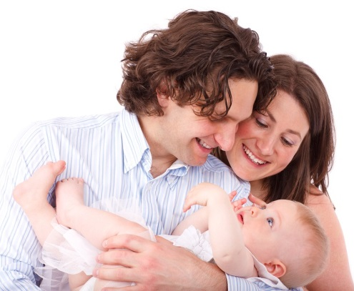
  En | que | sonríen
  los niños | hay | hablan
  unos padres | la foto | a su bebé
1.

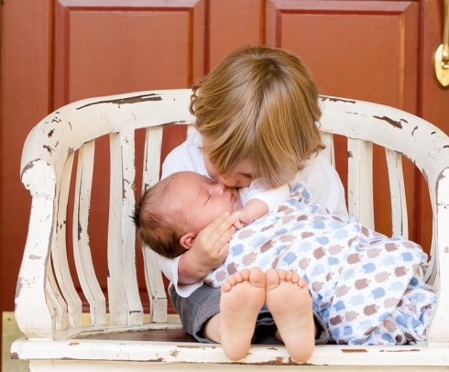
  a un niño | a un bebé | en
  su madre | En la | besa
  vemos | ver | su padre
  foto | que | juega


  ve | En | ver a
  los amigos | una fiesta | que
  podemos | bebida | comen
  celebran | una familia | la foto

Look at the two answers below and explain in detail to a partner what makes them different.
¿Qué piensas de tu mejor amigo/a?
- Yo pienso que él/ella es amable.
- Mi mejor amigo se llama Tom y él tiene dieciséis años como yo. Tiene el pelo castaño y corto y los ojos azules. Desde nuestra infancia nos conocemos y nos llevamos muy bien porque creo que él es divertido y agradable.

Practise asking and answering this question with a partner. Help each other to adapt and improve your replies and write the best version below.
¿Qué piensas de tu mejor amigo/a?

Choose three more questions from task B and prepare your answers.
Question | Answer

Now practise interviewing some other students using these questions. Give each other feedback on how to improve or extend the answers.

Exam practice tasks
Foundation assessment photo card  - Look at the photo during the preparation period.  - Make any notes you wish to on a separate piece of paper.  - Your teacher will then ask you questions about the photo and about the topic of friends and family.  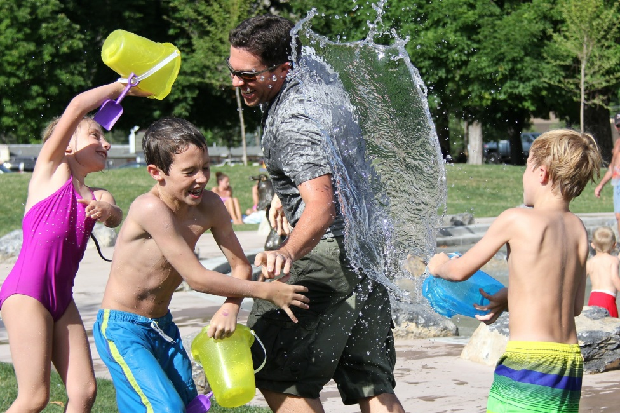  Your teacher will ask you the following three questions and then two more questions which you have not prepared.  - ¿Qué hay en la foto?  - ¿Te llevas bien con tus padres?  - Describe a el hermano / la hermana ideal. | Higher assessment photo card  - Look at the photo during the preparation period.  - Make any notes you wish to on a separate piece of paper.  - Your teacher will then ask you questions about the photo and about the topic of friends and family.    Your teacher will ask you the following three questions and then two more questions which you have not prepared.  - ¿Qué hay en la foto?  - ¿Cuáles son las cualidades de un buen amigo / una buena amiga?  - ¿Qué hiciste el fin de semana pasado con tus amigos(as)?

El matrimonio y la vida en pareja

Write your answers for each question.
To support you, use or adapt the Foundation or Higher ideas on the following pages.
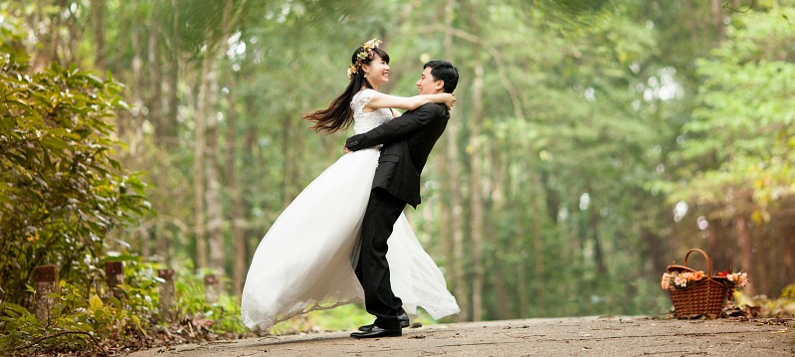
- ¿Qué hay en la foto?

- ¿Te quieres casar algún día?

- Describe a tu pareja ideal.

- ¿Cuántos hijos te gustaría tener?

- Estás organizando tu boda. Descríbela.

Match up the Spanish and the English questions in the grid below.
- ¿Qué hay en la foto? |  | - Describe your ideal partner.
- ¿Te quieres casar algún día? |  | - You are organising your wedding. Describe it.
- Describe a tu pareja ideal. |  | - What is there in the photo?
- ¿Cuántos hijos te gustaría tener? |  | - Do you want to get married one day?
- Estás organizando tu boda. Descríbela. |  | - How many children would you like to have?

1 = | 2 = | 3 = | 4 = | 5 =

Match up the beginnings of the following sentences with their correct endings.
- Hay un hombre y una … |  | - con el amor de mi vida.
- Sí, me gustaría casarme … |  | - muchos invitados.
- Él tiene que ser amable y … |  | - mujer que bailan.
- Yo no quiero … |  | - muy gracioso.
- Es una gran boda con … |  | - tener hijos.

1 = | 2 = | 3 = | 4 = | 5 =

1. ¿Qué hay en la foto?
En la foto | hay  vemos a  podemos ver a | una pareja  unos recién casados | que | baila(n).  se divierte(n).

2. ¿Te quieres casar algun día?
Sí, me gustaría casarme | con alguien | que me comprenda.  muy simpático(a)/rico(a).  que comparta mis intereses.
Sí, me gustaría casarme | porque | yo no quiero vivir solo(a).  yo creo en el matrimonio.  es importante para mí.
No, yo no quiero casarme | porque | quiero ser independiente.  prefiero quedarme soltero(a).  yo no creo en el matrimonio.  no me interesa.

3. Describe a tu pareja ideal.
Para mí, él debe ser  Para mí, ella debe ser | amable/simpático/comprensivo/inteligente/gracioso.  amable/simpática/comprensiva/inteligente/graciosa.
Él/Ella debería tener | el pelo moreno/rubio/pelirrojo.  los ojos azules/marrones/negros/avellana/grises.
En mi opinión, | nos llevaríamos bien.  haríamos muchas cosas juntos.  tendremos los mismos intereses.  haríamos deportes juntos.

4. ¿Cuántos hijos te gustaría tener?
Me gustaría tener … hijos porque | me gustan mucho los niños.  los niños me divierten muchísimo.  en mi opinión, ellos son graciosos.  no tengo miedo de las responsabilidades.  quiero una familia numerosa.  pienso que seré un buen padre / una buena madre.
No quiero tener hijos porque | odio a los niños.  no tengo mucha paciencia.  me aburren.  no quiero perder mi libertad.  tengo miedo de las responsabilidades.

5. Estás organizando tu boda. Descríbela.
Si yo organizo mi boda, yo quiero que sea |  | grande/pequeña/simple/  no demasiado cara.
Habría | flores  una banda de músicos  un pastel grande  champán | y | comeríamos caviar.  también un karaoke.  podríamos bailar toda la noche.

Las redes sociales y la tecnología

Circle the options which make most sense in each sentence below.
1 | Yo leo / nunca hablo /regularmente mis mensajes en Facebook.
2 | Me gusta mucho veo / ver videos graciosos / aburridos en YouTube.
3 | Ayer por la tarde descargué / descargo mi serie preferida en la tableta.
4 | Compré / Compro a menudo mi ropa en Internet porque es menos caro / interesante que en la tienda.
5 | Utilizo internet para hacer investigaciones / encuestas para los deberes porque es más lento/ rápido.
6 | La próxima semana / La semana pasada, pasé dos horas en el ordenador jugando / haciendo a mi juego preferido.
7 | Me gusta mucho contestar/ contestado a las encuestas en Internet; pienso que es relajante / aburrido.
8 | ¡Snapchat es genial! Sin embargo, prefiero encontrarme con / hablar mis amigos en la cafetería porque es más ameno / inútil.
9 | En mi opinión, hay muchos lugares de descarga / descargar y por eso / pero pasamos mucho tiempo en Internet.
10 | Mi madre prefiere / odia las redes sociales; por cierto, ¡ella no tiene una cuenta en Facebook!

Match the questions and the answers in the grid below.
- ¿Tienes móvil? |  | - Do you spend a lot of time on the internet?
- ¿Qué haces normalente en Internet? |  | - Do you have a mobile phone?
- ¿Pasas mucho tiempo en Internet? |  | - Do you often shop online?
- ¿Prefieres descargar películas o comprar los DVDs? |  | - What do you usually do on the internet?
- ¿Cuáles son las ventajas y los inconvenientes de las redes sociales? |  | - What did you do on the internet last weekend?
- ¿Qué hiciste en Internet el fin de semana pasado? |  | - Do you prefer downloading films or buying DVDs?
- ¿Haces compras por Internet a menudo? |  | - What are the advantages and disadvantages of social media?

1 = | 2 = | 3 = | 4 = | 5 = | 6 = | 7 =

Choose some of the words from each grid and put them in the right order to describe the photo. You won’t need all the words but start with ‘En’.

  hay | mira | trabaja
  En | una mujer | la televisión
  que | en el ordenador | la foto
1.


  En | descargan | que
  unos niños | ordenador | los chicos
  escuchan | la foto | vemos a
  en el | las chicas | juegan


  podemos | comparte | ver a
  está | En | que
  un niño | utilizando | su
  una chica | tableta | la foto

Look at the two answers below and explain in detail to a partner what makes them different.
¿Qué haces normalmente en Internet?
- Por lo general, pongo fotos de mis amigos en Instagram.
- Me paso horas en Snapchat ya que me permite mantener el contacto con mis amigos. Cuando estoy en Snapchat, me gusta compartir vídeos graciosos o fotos de mis amigos. ¡No puedo vivir sin él!

Practise asking and answering this question with a partner. Help each other to adapt and improve your replies and write the best version below.
¿Qué haces normalmente en Internet?

Choose three more questions from task B and prepare your answers.
Question | Answer

Now practise interviewing some other students using these questions. Give each other feedback on how to improve or extend the answers.

Exam practice tasks
Foundation assessment photo card  - Look at the photo during the preparation period.  - Make any notes you wish to on a separate piece of paper.  - Your teacher will then ask you questions about the photo and about the topic of technology in everyday life.  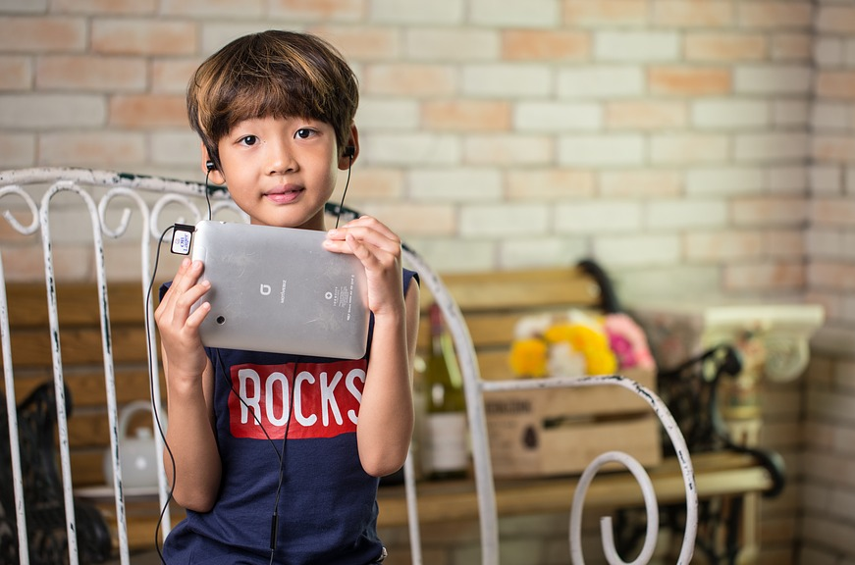  Your teacher will ask you the following three questions and then two more questions which you have not prepared.  - ¿Qué hay en la foto?  - ¿Pasas mucho tiempo en Internet?  - ¿Cuál es tu página web preferida y por qué? | Higher assessment photo card  - Look at the photo during the preparation period.  - Make any notes you wish to on a separate piece of paper.  - Your teacher will then ask you questions about the photo and about the topic of technology in everyday life.    Your teacher will ask you the following three questions and then two more questions which you have not prepared.  - ¿Qué hay en la foto?  - ¿Qué hiciste en Internet el fin de semana pasado?  - ¿Cuáles son las ventajas y los inconvenientes de las redes sociales?

Las tradiciones y las celebraciones

Write your answers for each question.
To support you, use or adapt the Foundation or Higher ideas on the following pages.

- ¿Qué hay en la foto?

- ¿Qué comes normalmente en Navidad?

- ¿Qué piensas de tus regalos?

- ¿Qué vas a regalar a tu familia para Navidad?

- Si no te gusta tu regalo, ¿qué haces?

Match up the Spanish and the English questions in the grid below.
- ¿Qué hay en la foto? |  | - You don’t like your gift. What do you do?
- ¿Qué comes normalmente en Navidad? |  | - What do you think of your presents?
- ¿Qué piensas de tus regalos? |  | - What is there in the photo?
- ¿Qué vas a regalar a tu familia para Navidad? |  | - What do you usually eat at Christmas?
- Si no te gusta tu regalo, ¿qué haces? |  | - What are you going to buy for your family for Christmas?

1 = | 2 = | 3 = | 4 = | 5 =

Fill in the answers to the five questions with the missing words provided.
- Hay una pequeña con un de Navidad.
- , yo como con .
- Me gustan mis porque estupendos.
- Yo voy a DVDs para mi familia.
- Yo los en la tienda.
regalo | cambio | niña | patatas | son
pavo | normalmente | regalos | mucho | comprar

1. ¿Qué hay en la foto?
En la foto | hay  vemos a  podemos ver a | una niña  mi hermana | que | va a abrir su regalo.  está delante del abeto.

2. ¿Qué comes normalmente para Navidad?
Normalmente para Navidad, como muchas cosas riquísimas.
Por ejemplo, yo como pavo |  | con | patatas.  judías verdes.  puré.
En cambio,  Sin embargo,  Por el contrario, | yo jamás como |  | coles de Bruselas  zanahorias  pescado
porque | la/las encuentro verdaderamente asquerosa(s).  me hace(n) querer vomitar.  me da(n) asco.

3. ¿Qué piensas de tus regalos?
Me gustan mucho | porque | yo siempre consigo lo que elijo/quiero.  son fantásticos/espectaculares.  mi familia conoce bien mis gustos.
A veces no me gustan | porque | yo no consigo lo que pedí.  son una porquería.  mi familia me compra cosas pasadas de moda.

4. ¿Qué vas a regalar a tu familia para Navidad?
Voy a intentar comprar regalos bonitos para mi familia.
Por ejemplo, voy a comprar …
un reloj bonito  una cámara fotográfica  una tableta  juguetes  videojuegos |  | para | mi padre.  mi madre.  mi hermano.  mi hermana.  mis primos/primas.
Yo espero | que esto le haga feliz.  que le guste su regalo.  que les encante su regalo.  que haya rebajas.  encontrar el regalo adecuado fácilmente.

5. Si no te gusta tu regalo, ¿que haces?
Cuando / si no me gusta mi regalo …
yo lo revendo en Ebay / en Internet.
yo lo intento cambiar en la tienda.
yo lo pongo en cualquier lugar de mi casa y lo olvido.
yo se lo doy a otra persona.
yo se lo digo a la persona que me lo dio.

Las obras caritativas y el voluntariado

Write your answers for each question.
To support you, use or adapt the Foundation or Higher ideas on the following pages.
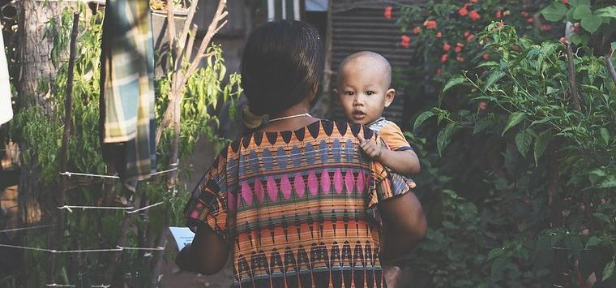
- ¿Qué hay en la foto?

- ¿Qué piensas del voluntariado?

- ¿Cuál es el problema más grave en el mundo en este momento?

- ¿Qué podemos hacer para combatir el hambre?

- Si tú fueras rico, ¿a qué ONG darías dinero?

Match up the Spanish and the English questions in the grid below.
- ¿Qué hay en la foto? |  | - If you were rich, which charity would you give to?
- ¿Qué piensas del voluntariado? |  | - What is there in the photo?
- ¿Cuál es el problema más grave en el mundo en este momento? |  | - What can we do to fight famine?
- ¿Qué podemos hacer para combatir el hambre? |  | - What do you think about volunteering?
- Si tú fueras rico, ¿a qué ONG darías dinero? |  | - What is the most serious problem in the world at the moment?

1 = | 2 = | 3 = | 4 = | 5 =

Fill in the answers to the five questions with the missing words provided.
- Hay una y un .
- En mi , el es importante.
- El problema más es la .
- Nosotros hacer donaciones de .
- Yo daría dinero a Médicos sin .
Fronteras | grave | mujer | podemos | dinero
niño | comida | guerra | opinión | voluntariado

1. ¿Qué hay en la foto?
En la foto | hay  vemos a  podemos ver a | una mujer | que lleva a un niño.  con su hijo.
En la foto | hay  vemos a  podemos ver a | un niño | que tiene un aspecto triste / cansado.  que nos mira.

2. ¿Qué piensas del voluntariado?
En mi opinión, es esencial | porque | es importante ayudar a otros.  es importante ser generoso.  no hay que ser egoísta.  debemos ayudar a las personas necesitadas.
Creo que es inútil | porque | es una pérdida de tiempo.  no resuelve los problemas reales.  siempre habrá pobres.

3. ¿Cuál es el problema más grave en el mundo en este momento?
En mi opinión, en este momento….
hay que  deberíamos  es imperativo | luchar contra enfermedades graves como el Ébola y el sida.  prevenir el calentamiento global.  eliminar la pobreza, ¡es inaceptable en estos tiempos!  combatir eficazmente el terrorismo.  ayudar a los países en desarrollo.  proporcionar acceso a agua potable para todos.

4. ¿Qué podemos hacer para combatir el hambre?
Para combatir el hambre …
hay que  deberíamos  debemos  podemos | organizar colectas de alimentos en los supermercados.  enviar paquetes de alimentos a los países que sufren de hambre.  organizar una manifestación para llamar la atención del público.  donar dinero a organizaciones como Oxfam.

5. Si tu fueras rico, ¿a qué ONG darías dinero?
Si yo tuviera mucho dinero, yo daría …
a Médicos sin Fronteras  a Amnistía Internacional  a la Cruz Roja  a Oxfam | para ayudar a los niños enfermos.  para liberar a los presos políticos.  para ayudar a los refugiados.  para crear un mundo más justo.

Los problemas medioambientales

Fill in the gaps with the correct Spanish words.
- malgastar la - to waste energy.
- apagar la - to turn off the lights.
- la calefacción – to turn down the heating.
- productos ecológicos – to buy organic products.
- ahorrar - to save water.
- el transporte público – to use public transport.
- reciclar el y el - to recycle glass and paper.
- en vez de – to take a shower

instead of a bath.
- dejar el abierto – to leave the tap running.
- utilizar el todo el tiempo – to use the car all the time.

Write the numbers 1-10 from task A in the correct column below.
Hay que | No hay que

Match the questions and the answers in the grid below.
- ¿Cómo vas al instituto? |  | - What are the issues in your town?
- ¿Qué se debería hacer para proteger el medio ambiente? |  | - What have you done to protect the environment?
- ¿Qué haces para proteger el medio ambiente? |  | - How do you get to school?
- ¿Cuáles son los problemas en tu ciudad? |  | - What should be done to protect the environment?
- ¿Qué vas a hacer para proteger el medio ambiente? |  | - What are you going to do to protect the environment?
- ¿Qué has hecho para proteger el medio ambiente? |  | - What do you do to protect the environment?

1 = | 2 = | 3 = | 4 = | 5 = | 6 =

Choose some of the words from each grid and put them in the right order to describe the photo. You won’t need all the words but start with ‘En’.
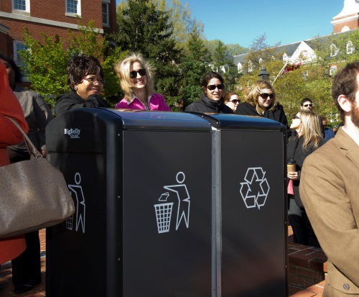
  personas | un chico | hay unas
  de reciclaje | En | los desechos
  la foto | contenedores | y dos
- .

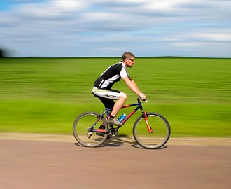
  En | que | una mujer
  la moto | va | vemos a
  un hombre | en bicicleta | un niño
  el patín | la foto | hace

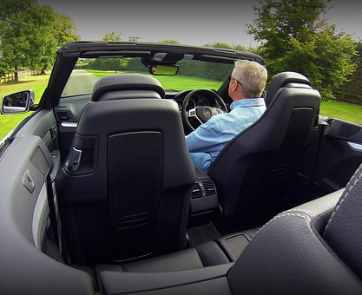
  un hombre | la foto | ver a
  un joven | una mujer | En
  podemos | conduce | coche
  que | un | una bicicleta

Look at the two answers below and explain in detail to a partner what makes them different.
¿Qué haces para proteger el medioambiente?
- Yo reciclo papel y vidrio.
- Todos los días, yo me ducho en vez de bañarme porque hay que ahorrar agua. Por otra parte, siempre me acuerdo de apagar la luz cuando salgo de una habitación porque creo que es importante proteger el medio ambiente.

Practise asking and answering this question with a partner. Help each other to adapt and improve your replies and write the best version below.
¿Qué haces para proteger el medioambiente?

Choose three more questions from task B and prepare your answers.
Question | Answer

Now practise interviewing some other students using these questions. Give each other feedback on how to improve or extend the answers.

Exam practice tasks
Foundation assessment photo card  - Look at the photo during the preparation period.  - Make any notes you wish to on a separate piece of paper.  - Your teacher will then ask you questions about the photo and about the topic of the environment.  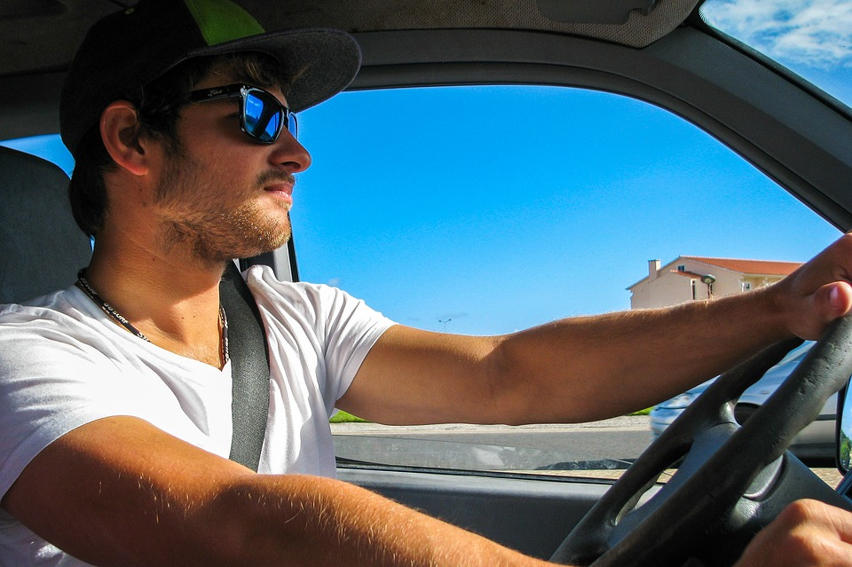  Your teacher will ask you the following three questions and then two more questions which you have not prepared.  - ¿Qué hay en la foto?  - ¿Qué hay que hacer para proteger el medioambiente?  - ¿Cuáles son los problemas en tu ciudad? | Higher assessment photo card  - Look at the photo during the preparation period.  - Make any notes you wish to on a separate piece of paper.  - Your teacher will then ask you questions about the photo and about the topic of the environment.  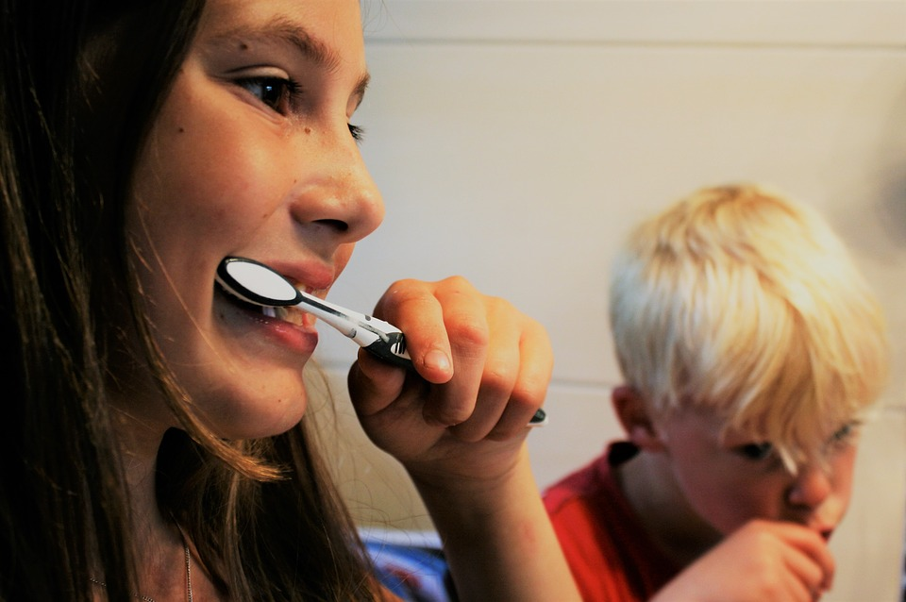  Your teacher will ask you the following three questions and then two more questions which you have not prepared.  - ¿Qué hay en la foto?  - ¿Qué has hecho recientemente para proteger el medioambiente?  - ¿Qué vas a hacer en el futuro?

La pobreza y los sin techo

Write your answers for each question.
To support you, use or adapt the Foundation or Higher ideas on the following pages.
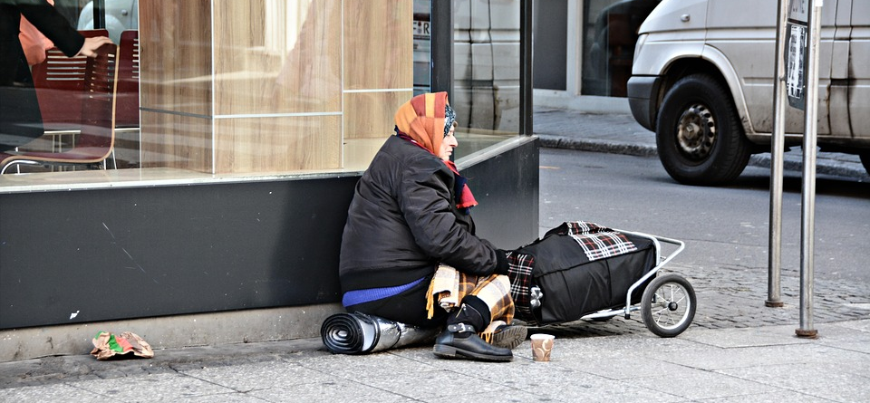
- ¿Qué hay en la foto?

- ¿Qué hay que hacer para eliminar la pobreza?

- ¿Cómo podemos ayudar a los sin techo?

- ¿Qué podríamos hacer para reducir el desempleo?

- ¿Qué harías tú si fueras un sin techo?

Match up the Spanish and the English questions in the grid below.
- ¿Qué hay en la foto? |  | - What would you do if you were homeless?
- ¿Qué hay que hacer para eliminar la pobreza? |  | - What is there in the photo?
- ¿Cómo podemos ayudar a los sin techo? |  | - What could we do to reduce unemployment?
- ¿Qué podríamos hacer para reducir el desempleo? |  | - What should be done to eliminate poverty?
- ¿Qúe harías tú si fueras un sin techo? |  | - How can we help homeless people?

1 = | 2 = | 3 = | 4 = | 5 =

Match up the beginnings of the following sentences with their correct endings.
- Hay … |  | - más empleos.
- Hay que dar dinero a … |  | - un sin techo/ persona sin hogar delante de una tienda.
- Podemos darles … |  | - en la calle.
- Podríamos crear … |  | - buenas causas.
- Yo mendigaría … |  | - para comer.

1 = | 2 = | 3 = | 4 = | 5 =

1. ¿Qué hay en la foto?
En la foto | hay  vemos a  podemos ver a | una señora  un sin techo  una persona | que | mendiga.  parece infeliz/triste.  esta sentada en la calle.

2. ¿Qué hay que hacer para eliminar la pobreza?
Para eliminar la pobreza, yo pienso que …
hay que  se debería | dar dinero para buenas causas.  presionar al gobierno mediante la firma de peticiones.  aumentar los salarios bajos.  hacer donaciones a bancos de alimentos.  participar políticamente.

3. ¿Cómo podemos ayudar a los sin techo?
En mi opinión, podemos ayudar a los sin techo …
en la búsqueda de alojamiento.
presionando a los políticos.
dándoles comidia y bebida.
con la organización de los comedores populares.

4. ¿Qué podríamos hacer para reducir el desempleo?
Para reducir el desempleo …
podríamos | dar trabajo a todo el mundo.  crear más empleos.  mejorar la educación.  animar a la gente a que se forme.

5. ¿Qué harías tú si fueras un sin techo?
Si yo fuera un sin techo | pediría dinero a los peatones.  mendigaría.  trataría de encontrar una vivienda.  iría a comer a un comedor.

El trabajo y elegir profesión

Label the pictures below with Spanish jobs.
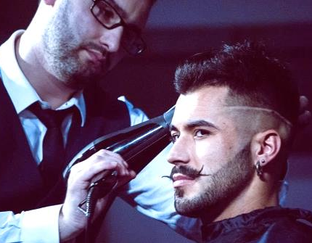 | 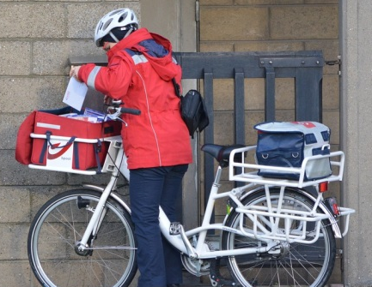 | 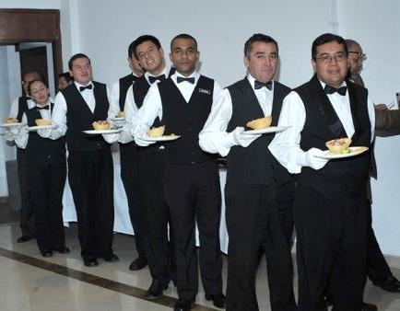
1. | 2. | 3.
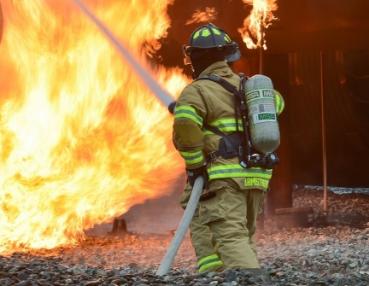 | 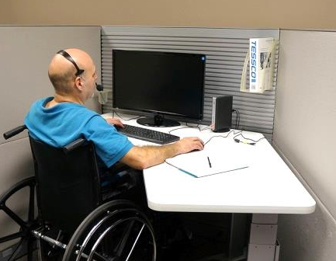 | 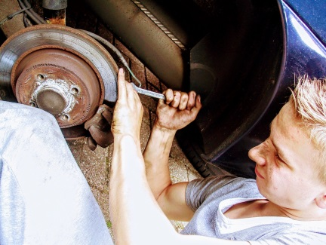
4. | 5. | 6.
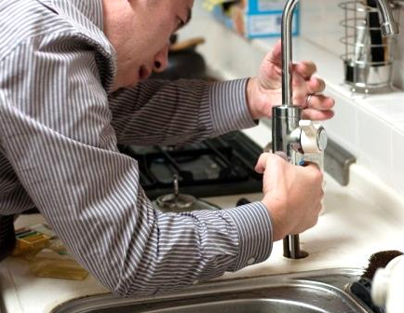 |  | 
7. | 8. | 9.
 | 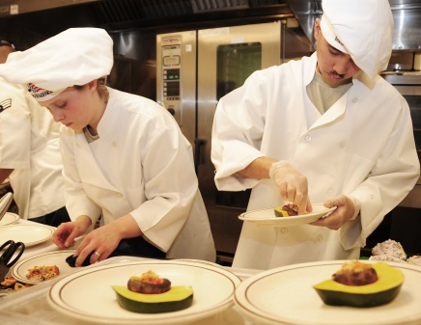 | 
10. | 11. | 12.

Match the questions and the answers in the box below.
- ¿Te gustaría ser profe? |  | - Where did you do your work experience?
- ¿Trabajas los sábados? |  | - What job are you going to do in the future?
- ¿En qué trabajan tus padres? |  | - Do they like their job?
- ¿Les gusta su trabajo? |  | - Would you like to be a teacher?
- ¿Cuáles son los problemas en el trabajo, en tu opinión? |  | - Do you have a Saturday job?
- ¿Dónde hiciste tus prácticas de trabajo? |  | - What job do your parents do?
- ¿Qué trabajo vas a hacer en el futuro? |  | - What are the problems at work in your opinion?

1 = | 2 = | 3 = | 4 = | 5 = | 6 = | 7 =

What other questions might come up on this topic?

Choose some of the words from each grid and put them in the right order to describe the photo. You won’t need all the words but start with ‘En’.

  hay | los clientes | la foto
  a sus clientes | En | una banquera
  que | un médico | habla
1.
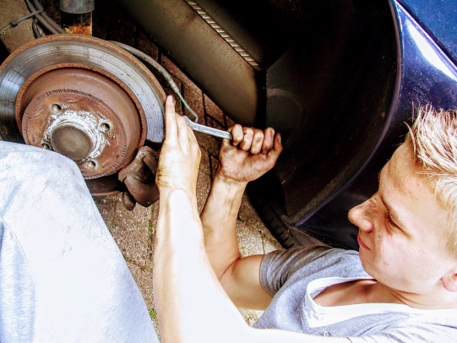
  En | un coche | un mecánico
  un garage | que | un autobús
  vemos a | un carpintero | una bicicleta
  salva | repara | la foto
2.

  a un | repara | foto
  podemos | una bombilla | ve
  la | En | electricista
  que | ver | una toma de corriente
3.

Fill in the gaps for these model answers with the missing words provided.
- Yo en un centro de ocio.
- Mi padre es contable en un .
- Mi madre es en un hospital grande.
- Más adelante, me gustaría ser porque me encantan los idiomas.
- No me gusta mucho mi trabajo porque el es . .
- En mi , en el trabajo, el problema es la .
- Yo pienso que mi trabajo está .
- En el trabajo con mis compañeros porque son amables.
- Más adelante, me gustaría policía.
- Durante mis prácticas , yo estaba a cargo de los niños.
discriminación | mal pagado | hacerme | jefe
yo me llevo bien | despacho | en una escuela | trabajo
profesor de español | médica | malo | opinión

Look at the two answers below and explain in detail to a partner what makes them different.
¿Dónde hiciste las prácticas?
- Hice las prácticas en el garaje de mi padre.
- Hice mis prácticas en un garaje durante unas dos semanas. Creo que fue una experiencia muy positiva, porque he aprendido mucho sobre los coches. Además, el jefe y mis compañeros siempre fueron amables.

Practise asking and answering this question with a partner. Help each other to adapt and improve your replies and write the best version below.
¿Dónde hiciste las prácticas?

Choose three more questions from task B and prepare your answers.
Question | Answer

Now practise interviewing some other students using these questions. Give each other feedback on how to improve or extend the answers.

Exam practice tasks
Foundation assessment photo card  - Look at the photo during the preparation period.  - Make any notes you wish to on a separate piece of paper.  - Your teacher will then ask you questions about the photo and about the topic of jobs and career choices.  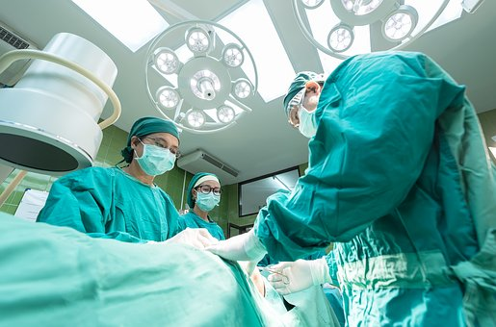  Your teacher will ask you the following three questions and then two more questions which you have not prepared.  - ¿Qué hay en la foto?  - ¿Tienes un trabajo ocasional?  - ¿Te gusta tu trabajo? | Higher assessment photo card  - Look at the photo during the preparation period.  - Make any notes you wish to on a separate piece of paper.  - Your teacher will then ask you questions about the photo and about the topic of jobs and career choices.  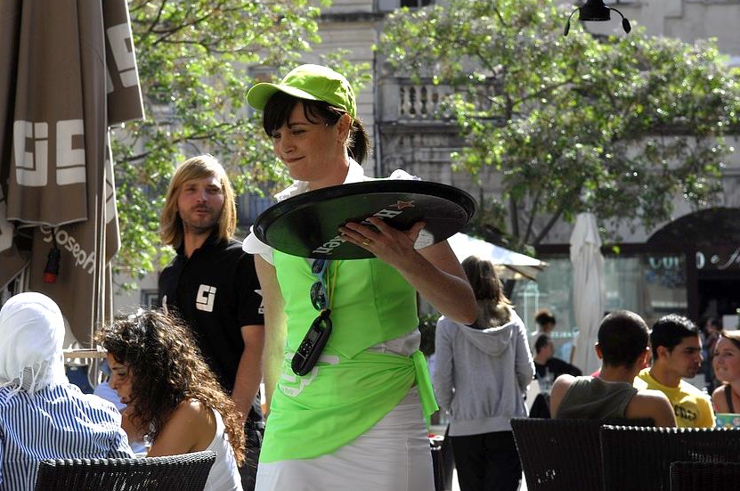  Your teacher will ask you the following three questions and then two more questions which you have not prepared.  - ¿Qué hay en la foto?  - ¿En qué trabajan tus padres?  - ¿Qué trabajo vas a hacer más adelante?

Photo card answers
Photo cards answers

Los amigos y la familia (pp.37-41)

1 = d | 2 = f | 3 = h | 4 = i | 5 = c | 6 = j
7 = l | 8 = k | 9 = b | 10 = a | 11 = g | 12 = e

1 = c | 2 = e | 3 = g | 4 = f | 5 = d | 6 = a | 7 = b

- En la foto hay unos padres que sonríen a su bebé.
- En la foto vemos a un niño que besa a un bebé.
- En la foto podemos ver a los amigos que celebran una fiesta.

El matrimonio y la vida en pareja (pp.42-45)
B.
1 = c | 2 = d | 3 = a | 4 = e | 5 = b
C.
1 = c | 2 = a | 3 = d | 4 = e | 5 = b

Las redes sociales y la tecnología (pp.46-50)
A.
- Yo leo regularmente mis mensajes en Facebook.
- Me gusta mucho ver videos graciosos en YouTube.
- Ayer por la tarde descargué mi serie preferida en la tableta.
- Compro a menudo mi ropa en Internet porque es menos caro que en la tienda.
- Utilizo Internet para hacer investigaciones para los deberes porque es más rápido.
- La semana pasada, pasé dos horas en el ordenador jugando a mi juego preferido.
- Me gusta mucho contestar a las encuestas en Internet; pienso que es relajante.
- ¡Snapchat es genial! Sin embargo prefiero encontrarme con mis amigos en la cafetería porque es más ameno.
- En mi opinión, hay muchos lugares de descarga y por eso pasamos mucho tiempo en Internet.
- Mi madre odia las redes sociales; por cierto, ¡ella no tiene una cuenta en Facebook!
B.
1 = b | 2 = d | 3 = a | 4 = f | 5 = g | 6 = e | 7 = c

C.
- En la foto, hay una mujer que trabaja en el ordenador.
- En la foto vemos a unos niños que juegan en el ordenador.
- En la foto podemos ver a una chica que está utilizando su tableta.

Las tradiciones y las celebraciones (pp.51-54)
B.
1 = c | 2 = d | 3 = b | 4 = e | 5 = a
C.
- Hay una niña pequeña con un regalo de Navidad.
- Normalmente, yo como pavo con patatas.
- Me gustan mucho mes regalos porque son estupendos.
- Yo voy a comprar DVDs para mi familia.
- Yo los cambio en la tienda.

Las obras caritativas y el voluntariado (pp.55-58)
B.
1 = b | 2 = d | 3 = e | 4 = c | 5 = a
C.
- Hay una mujer y un niño.
- En mi opinión, el voluntariado es importante.
- El problema más grave es la guerra.
- Nosotros podemos hacer las donaciones de comida.
- Yo donaría dinero a Médicos sin Fronteras.

Los problemas medioambientales (pp.59-63)
A.
- Malgastar la energía – to waste energy.
- Apagar la luz – to turn off the lights.
- Bajar la calefacción – to turn down the heat.
- Comprar productos ecológicos – to buy organic products.
- Ahorrar agua – to save water.
- Utilizar el transporte público – to use public transport.
- Reciclar el vidrio y el papel – to recycle glass and paper.
- Ducharse en vez de bañarse – to have a shower instead of a bath.
- Dejar el grifo abierto – to leave the tap running.
- Utilizar el coche todo el tiempo – to use the car all the time.
B.
Hay que | No hay que
2 / 3 / 4 / 5 /6 / 7 / 8 | 1 / 9 / 10

C.
1 = c | 2 = d | 3 = f | 4 = a | 5 = e | 6 = b
D.
- En la foto, hay unas personas y dos contenedores de reciclaje.
- En la foto vemos a un hombre que va en una bicicleta.
- En la foto podemos ver a un hombre que conduce un coche.

La pobreza y los sin techo (pp.64-66)
B.
1 = b | 2 = d | 3 = e | 4 = c | 5 = a
C.
1 = b | 2 = d | 3 = e | 4 = a | 5 = c

El trabajo y elegir profesión (pp.67-72)
A.
- peluquero(a) | - cartero(a) | - camarero(a)
- bombero(a) | - secretario(a) | - mecánico(a)
- fontanero(a) | - profesor(a) | - enfermero(a)
- policía | - cocinero(a) | - médico(a)
B.
1 = d | 2 = e | 3 = f | 4 = c | 5 = g | 6 = a | 7 = b
C.
- En la foto hay una banquera que habla a sus clientes
- En la foto vemos a un mecánico que repara un coche.
- En la foto podemos ver a un electricista que repara una toma de corriente.
D.
- Yo trabajo en un centro de ocio.
- Mi padre es contable en un despacho.
- Mi madre es médica en un hospital grande.
- Más adelante, me gustaría ser profesor de español porque me encantan los idiomas.
- No me gusta mucho mi trabajo porque el jefe es malo.
- En mi opinión, en el trabajo, el problema es la discriminación.
- Yo pienso que mi trabajo está mal pagado.
- En el trabajo yo me llevo bien con mis compañeros porque son amables.
- Más adelante, me gustaría hacerme en policía.
- Durante mis prácticas en una escuela, yo estaba a cargo de los niños.

© Maryland GovPics, 2012, flic.kr/p/bvq9rS

General conversation

Teaching notes
This section of the pack is designed to help students prepare for the general conversation part of the exam and is made up of the following parts:
- Asking questions: tips, worksheets and dice speaking games.
- Key ingredients: differentiated ideas for language to include, common verbs in different tenses and worksheets with assessment grids.
- Practice questions: four suggested questions for each topic (making sixteen questions in total for each of the three themes), with a pair work speaking game for each theme. This allows students to prepare and practise some answers to learn in advance and to decide which will be their nominated conversation topic.

The themes and topics are organised as follows:
Themes | Topics
La identidad y la cultura | - Los amigos y la familia  - Las redes sociales y la tecnología  - Los pasatiempos  - Las fiestas y las tradiciones españolas
Las cuestiones locales, nacionales e internacionales | - Donde vivo  - Las cuestiones sociales  - Las cuestiones globales  - El turismo
Los estudios y el trabajo | - Mis estudios  - La vida en la universidad  - Después de la universidad  - El trabajo, elegir profesión y las ambiciones.

Answers are provided at the end of the general conversation section, on pp.100-101.

Asking questions
During the general conversation part of the test you will have to ask your teacher a question. Remember, you’ll need to address your teacher as ‘usted’.

Top tip
When asked your opinion, give your answer and then ask your teacher their opinion on the topic you are discussing.
You could use the following language:
- ¿Y usted? And you?
- ¿Le gusta … ? Do you like … ?
- ¿Qué prefiere usted? What do you prefer?
- ¿Qué piensa usted? What do you think of it?
- ¿Cuál es su opinión sobre … ? What is your opinion of … ?

Choose the best question to ask.
What question could you ask your teacher to complete each of the dialogues below? Use the tips above to help you. There might be more than one possibility.

Teacher: ¿Prefieres viajar al extranjero o permanecer en Gran Bretaña?
Student: Prefiero viajar al extranjero porque es más interesante.
- ?

Teacher: ¿Te gusta la música?
Student: Si, me encanta la música rock.
- . ?

Teacher: ¿Cuáles son las ventajas y desventajas de tu ciudad o tu pueblo?
Student: Mi pueblo es tranquilo pero no hay transporte público, por lo que no me gusta mucho vivir allí.
- ?

Teacher: ¿Está prohibido el uso del ordenador portátil en tu instituto? ¿Es una cosa buena o no?
Student: Podemos utilizarlo en clase para investigar en Internet y en mi opinión es muy útil.
- . ?

Teacher: ¿Qué piensas del cambio climático? ¿Es grave?
Student: Sí, creo que es uno de los problemas mundiales más graves.
- ?


Top tip
When asked a question, give your answer and then adapt the same question to ask your teacher the same thing.
Example:
Teacher: ¿Qué hiciste en la ciudad el fin de semana pasado?
Student: Fui de compras con mis amigos y me compré un portátil nuevo. ¿Qué hizo usted?

Adapting questions
Adapt each of the questions asked by the teacher below in order to ask the same thing. Remember to use ‘usted’!
Teacher: ¿Quién es tu mejor amigo/amiga y por qué?
Student: Mi mejor amigo se llama Tom y me gusta mucho porque es muy amable y súper divertido.
- ?

Teacher: ¿A qué fiesta española/hispanohablante le gustaría asistir?
Student: Me gustaría visitar Madrid para asistir a la fiesta nacional de España el 12 de octubre porque he visto vídeos en Internet. Yo pienso que el desfile de las fuerzas armadas es impresionante.
- ?

Teacher: ¿Has visto alguna película buena recientemente?
Student: La semana pasada vi una pelicula española que se llama El laberinto del Fauno.
- ?

Teacher: ¿Qué vas a hacer durante las vacaciones de verano?
Student: Voy a pasar tres semanas con mi abuela en Edimburgo. ¡Tengo muchas ganas de ir!
- ?

Teacher: ¿Qué harías tú si fueras el director del instituto?
Student: Yo diría que el aprendizaje de una lengua extranjera debería ser obligatorio para todo el mundo ¡incluyendo a los profesores!
- ?

Top tip
If you don’t understand a question, make sure you ask for clarification, as this can help you respond successfully. However, this won’t count as the question you need to ask!
You could say:
- ¿Puede repetir, por favor?
- No comprendo.

Make sure you can understand question words! Write the English below.
Español | Inglés
Dónde
Cuándo
Cuánto/ Cuánta/ Cuántos/ Cuántas
Por qué
Cuál/Cuáles
A qué hora
Quién/ Quiénes
Cómo
Acaso…
Qué es…

Dice speaking games
Use a dice and the speaking grids to help you practise asking questions with a partner. If you need more support, start with the Spanish grid first and translate the questions into English. Then move onto the English grid, using the Spanish grid to check answers.

Instructions
- Take turns to roll twice in order to pick a specific square. For example, by rolling a one and then a two, you could choose to translate either ‘What is your opinion of the internet’ or ‘Do you prefer French or Spanish cuisine?’
- Translate the question in that square and if your partner agrees that the translation is correct, put a counter on that square or pencil your initials on it.
- The winner is the first person to get four squares in a row or the person with the most squares claimed at the end of the allotted time.
- Remember to use the ‘usted’ form in Spanish, as you are practising questions to ask your teacher.

Spanish speaking grid
 |  |  |  |  |  | 
 | ¿Y usted? | ¿Prefiere usted la comida francesa o española? | ¿Cuál es su opinión sobre los sin techo? | ¿Ha visto usted algún documental recientemente? | ¿Cuál es su opinión sobre el fútbol? | ¿Le gusta viajar?
 | ¿Cuál es su opinión sobre internet? | ¿Le gusta el deporte? | ¿Qué va a hacer este fin de semana? | ¿Qué haría si fuera rico? | ¿Qué prefiere, la natación o el baile? | ¿Cuál es su comida favorita?
 | ¿Prefiere usted Twitter o Snapchat? | ¿Dónde le gustaría vivir? | ¿Le gusta ver las noticias? | ¿Qué piensa de los deberes? | ¿Cuál es su opinión sobre el gobierno? | ¿Le gusta la musica rap?
 | ¿Quién es su cantante favorito? | ¿Qué prefiere usted? | ¿Quién es su actor favorito? | ¿Cuál es su pelicula favorita? | ¿Prefiere el vino o la cerveza? | ¿Cuál es /era su asignatura favorita?
 | ¿Que hizo usted en el instituto ayer? | ¿Qué película le gustaría ver? | ¿Le gusta cocinar? | ¿Qué piensa sobre eso? | ¿Ha visto alguna película de terror? | ¿Le gusta ir al cine?
 | ¿Qué le gustaría beber? | ¿Tiene usted algún hobby? | ¿Cuál es su opinión sobre el reciclaje? | ¿Cuál es su ONG favorita? | ¿Qué prefiere, francés o español? | ¿Qué país le gustaría visitar?

English speaking grid
 | And you? | Do you prefer French or Spanish cuisine? | What is your opinion of the homeless? | Have you watched a documentary recently? | What is your opinion of football? | Do you like travelling?
 | What is your opinion of the internet? | Do you like sport? | What are you going to do this weekend? | What would you do if you were rich? | What do you prefer, swimming or dancing? | What is your favourite food?
 | Do you prefer Twitter or Snapchat? | Where would you like to live? | Do you like watching the news? | What do you think of homework? | What is your opinion of the government? | Do you like rap music?
 | Who is your favourite singer? | What do you prefer? | Who is your favourite actor? | What’s your favourite film? | Do you prefer wine or beer? | What is/was your favourite subject?
 | What did you do at school yesterday? | Which film would you like to see? | Do you like cooking? | What do you think of it? | Have you watched a horror film? | Do you like going to the cinema?
 | What do you like to drink? | Do you have any hobbies? | What is your opinion of recycling? | Which is your favourite charity? | What do you prefer, French or German? | Which country would you like to visit?

Key ingredients

Top tip
Show off your knowledge of Spanish structures, vocabulary and tenses – and show how accurately you can use them at your own level. Here are some ideas of the type of language you could try and include in your answers, categorised into bronze, silver and gold levels. You can add your own ideas too!
To hit higher grades you will need to develop your answers, using more complex sentences, a range of different tenses and justified opinions, narrating events where relevant.

Bronze

Adjectives and adverbs
Adjectives | Adverbs
pesado / generoso / divertido / grosero / pequeño / grande | muy / bastante / un poco / demasiado / realmente / extremadamente / muchísimo
Mi madre es pequeña y divertida.* *Remember adjective agreements. | Mi hermano es muy pesado.

Connectives and subordinate clauses
Connectives | Subordinate clauses
pues / por lo tanto / después / y / pero / o / o bien / luego / porque | quien / que / donde
Me gusta mi casa porque está en un lugar muy tranquilo. | Mi pueblo, que se encuentra en el suroeste de Inglaterra, tiene 45 000 habitantes.
Opinions and justifications
Opinions | Justifications
me encanta(n) / detesto / no me gusta(n) / encuentro que / en mi opinión / pienso que / creo que | porque / pues / a causa de / ya que
Me encanta el español porque es interesante y útil.

Comparatives and superlatives
Comparatives | Superlatives
más … que / menos … que / tan… como | el más / el menos / el mejor / el peor
El salón es tan grande como el comedor. | Mi profesor de mates es el* más estricto.  *Change ‘el’ to ‘la’, ‘las’ or ‘los’ if necessary.

Time phrases (see verb tables on pp.88-89 for common verbs in three time frames)
Past | Present | Future
Ayer  Antes  En otro tiempo  En fin de semana pasado  El verano pasado  La semana pasada | Hoy  Hoy en día  Ahora  En este momento | Mañana  En el futuro  Más adelante
Use ‘desde hace’ with the present tense: Yo vivo aquí desde hace cinco años.

Silver

Include all the ideas from the bronze section above and add the following elements.

Direct and indirect pronouns
lo / la / los / las | me / le / les
Yo lo odio.  Yo la encuentro difícil.  Yo los veo el fin de semana.  Yo las vi ayer. | Mis padres me dan £10 a la semana.  Yo le dije que había olvidado mis deberes.

Modal verbs
Modal verb | Example
deber | Mi entrenador me dijo que debería comer más frutas y verduras.
saber | No sé lo que haré más adelante en la vida.
querer | Mi hermana no quiere buscar trabajo.
poder | En mi ciudad los turistas pueden visitar el museo de arte moderno.

Perfect infinitive
despues de haber + past participle | Despues de haber hecho mis deberes, salí.
haber + past participle | Me arrepiento de haber gritado a mi profesor.

Present participle
Me rompí la pierna jugando al fútbol en el parque.
Me gusta hacer los deberes escuchando música, es más relajante.

Pluperfect tense
Las vacaciones fueron desastrosas porque llegamos a la estación de tren tarde y el tren ya se había ido.
Para mi cumpleaños me dieron un libro pero era una historia que había leído cuando era más joven.

‘If’ sentences with present and future tenses
si + present + future | Este fin de semana, si hace buen tiempo, iremos a la playa.

Gold

Include the ideas from the bronze and silver sections and add the following elements.

Compound verb tenses
Conditional perfect | Habría hecho mis deberes con gusto pero yo estaba enfermo.
Future perfect | Cuando cumpla 18 años yo habré terminado mis examenes e iré de vacaciones.

Passive voice
Future | La nueva estación será abierta en dos meses.
Perfect | El cine fue cerrado a causa del fuego.
Imperfect | El jardín estaba cubierto de nieve.

Subjunctive mood
a pesar de que | A pesar de que raramente haga ejercicio, estoy en forma.
siempre que | Siempre que seas amable, tendrás amigos.
yo no pienso que | Yo no pienso que los deberes sean necesarios.
tan pronto como | Tan pronto como nieve, iremos a la montaña.

‘If’ sentences with complex tenses
si + imperfect subjunctive + conditional | Si esta asignatra fuera fácil, la comprendería fácilmente.
si + pluperfect subjunctive + conditional perfect | Si hubiera tenido la opción, yo habría elegido el italiano (en lugar de alemán).

Verb tables
Common present tense verbs
Yo soy | I am | El/Ella es | He/She is
Yo tengo | I have | El/Ella tiene | He/She has
Yo hago | I do/make | El/Ella hace | He/She does/makes
Yo voy | I go | El/Ella va | He/She goes
Yo como | I eat | El/Ella come | He/She eats
Yo miro | I watch | El/Ella mira | He/She watches
Yo juego | I play | El/Ella juega | He/She plays
Yo escucho | I listen | El/Ella escucha | He/She listens
Yo bebo | I drink | El/Ella bebe | He/She drinks
Yo trabajo | I work | El/Ella trabaja | He/She works
Yo leo | I read | El/Ella lee | He/She reads
Yo llevo | I wear | El/Ella lleva | He/She wears

Common perfect/preterite/imperfect tense verbs
Yo he estado/sido | I have been | Yo era/estaba | I was / used to be
Yo he tenido | I have had | Yo tenía/tuve | I had / used to have
Yo hice | I did/made | Yo hacía | I used to do/make
Yo fui | I went | Yo iba | I used to go
Yo comí | I ate | Yo comía | I used to eat
Yo ví | I watched | Yo veía | I used to watch
Yo jugué | I played | Yo jugaba | I used to play
Yo escuché | I listened | Yo escuchaba | I used to listen
Yo bebí | I drank | Yo bebía | I used to drink
Yo trabajé | I worked | Yo trabajaba | I used to work
Yo leí | I read | Yo leía | I used to read
Yo llevé | I wore | Yo llevaba | I used to wear

Common future/conditional tense verbs
Yo seré | I will be | Yo sería | I would be
Yo tendré | I will have | Yo tendría | I would have
Yo haré | I will do / make | Yo haría | I would do / make
Yo iré | I will go | Yo iría | I would go
Yo comeré | I will eat | Yo comería | I would eat
Yo miraré | I will watch | Yo miraría | I would watch
Yo jugaré | I will play | Yo jugaría | I would play
Yo escucharé | I will listen | Yo escucharía | I would listen
Yo beberé | I will drink | Yo bebería | I would drink
Yo trabajaré | I will work | Yo trabajaría | I would work
Yo leeré | I will read | Yo leería | I would read
Yo llevaré | I will wear | Yo llevaría | I would wear

Assessment grids: school

Identify which ingredients have been included in this student’s answer on the topic of school subjects. Tick all those used. You may spot mistakes!
Question: Háblame de las asignaturas en el instituto.
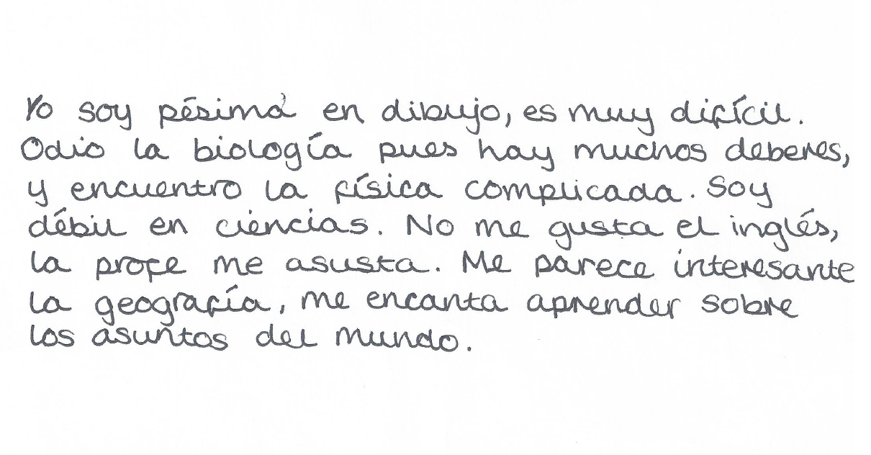

adjectives | adverbs | connectives | subordinate clauses
opinions | justifications | comparatives | superlatives
pronouns | negatives | present tense (‘yo’ form) | present tense (form other than ‘yo’)
past | future | compound tense | modal verbs

- Write a similar answer to the same question, adding one or more extra ingredients from the assessment grid.
Question: Háblame de las asignaturas en el instituto.

- Swap your work with a partner and tick all the ingredients used in their work.
adjectives | adverbs | connectives | subordinate clauses
opinions | justifications | comparatives | superlatives
pronouns | negatives | present tense (‘yo’ form) | present tense (form other than ‘yo’)
past | future | compound tense | modal verbs

- Write some feedback for your partner on what they did well and what they could improve.
Feedback

Assessment grids: family
- Identify which ingredients have been included in this student’s answer on the topic of the family. Tick all those used. You may spot mistakes!
Question: Describe a tu familia.
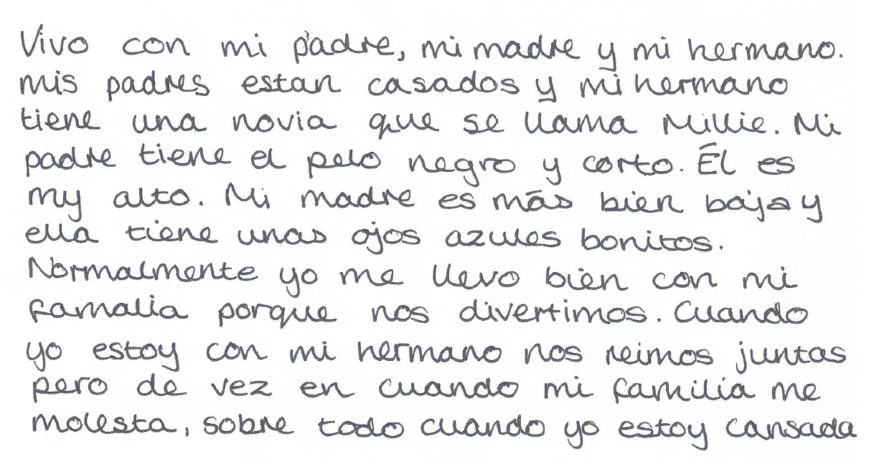

adjectives | adverbs | connectives | subordinate clauses
opinions | justifications | comparatives | superlatives
pronouns | negatives | present tense (‘yo’ form) | present tense (form other than ‘yo’)
past | future | compound tense | modal verbs

- The first part of the answer above uses short sentences. Rearrange the sentence parts below to form longer sentences. Translate the sentences into English.

bastante simpáticos | que están casados, | Mis padres | son normalmente | y amables

se llama Mathis | con quien yo | a menudo, | me peleo | Mi hermano,

novia, Millie, | Él sale | tres años | con su | desde hace

las islas Mauricio, | Mi padre, | tiene el pelo | que es de | negro y corto

pequeña | mucho más | grande que mi | Mi padre es | madre, que es

Practice questions
La identidad y la cultura

Los amigos y la familia
- Describe a tu familia. ¿Es grande o pequeña?
- ¿Quién es tu mejor amigo/amiga? ¿Cuáles son sus cualidades?
- ¿Te llevas bien con tu familia? ¿Por qué? / ¿por qué no?
- ¿Te gustaría casarte / tener hijos en el futuro?

Las redes sociales y la tecnología
- ¿Cuánto tiempo pasas en Internet cada semana? ¿Qué páginas de internet prefieres?
- ¿Está prohibido utilizar ordenador portátil en tu instituto? ¿Es una cosa buena o no?
- ¿Serías capaz de pasar una semana sin acceso a Internet? ¿Qué harías para pasar el tiempo?
- ¿Qué opinas del vehículo autónomo? ¿Te gustaría viajar en un coche sin conductor? ¿Por qué (no)?

Los pasatiempos
- ¿Cuál es tu deporte favorito? ¿Lo practicas a menudo?
- ¿Qué hiciste el fin de semana pasado? ¿Cómo fue?
- ¿Tienes suficiente tiempo libre? ¿Por qué (no)?
- ¿Qué hobbies tenías cuando eras más joven? ¿Eran muy diferentes de lo que haces ahora?

Las fiestas y las tradiciones españolas
- Describe la fiesta nacional española. ¿Cuándo y por qué se lleva a cabo?
- ¿Es importante que España celebre su cultura? ¿Por qué?
- ¿A qué fiesta española/hispanohablante te gustaría ir?
- ¿Crees que los festivales españoles son mejores que los festivales británicos? ¿Por qué (no)?

Snakes and ladders speaking game
Roll a dice to move forward. Answer the question you land on or move back one square. Climb up ladders and slide down snakes.
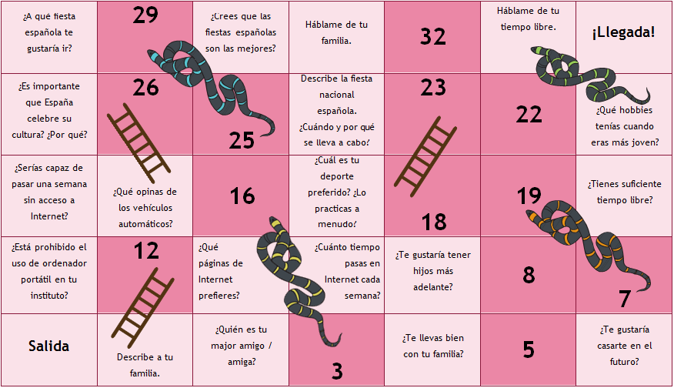

Practice questions
Las cuestiones locales, nacionales e internacionales

Donde vivo
- ¿Desde cuando vives en tu ciudad / pueblo?
- ¿Cuáles son las ventajas y desventajas de tu ciudad / pueblo?
- ¿Qué hiciste en la ciudad el fin de semana pasado? ¿Con quién? ¿Cómo fue?
- ¿Qué pueden los turistas ver / visitar en tu región?

Las cuestiones sociales
- ¿Cuáles son los problemas de tu región? (¿Desempleo? ¿Contaminación? ¿Los sin techo?)
- ¿Qué opinas de los periódicos de la calle como The Big Issue?
- ¿Tu instituto organiza eventos para recaudar dinero para obras de caridad? Si es así, ¿qué hacéis?
- Si tú fueras el alcalde, ¿qué harías para mejorar tu ciudad/pueblo?

Las cuestiones globales
- ¿Qué opinas del cambio climático? ¿Es muy grave en tu opinión?
- ¿Estas interesado en la política? ¿Por qué (no)?
- Si tú fueras el Primer Ministro, ¿qué harías para mejorar la situación del mundo?
- ¿Los países ricos deben ayudar a los países en desarrollo? ¿Qué es mejor, ofrecerles dinero o alguna otra cosa?

El turismo
- ¿Prefieres pasar las vacaciones en Gran Bretaña o en el extranjero? ¿Por qué?
- ¿Cuáles son las ventajas y las desventajas de ir de vacaciones en familia?
- ¿Cómo serían tus vacaciones ideales?
- ¿Cómo pasabas tus vacaciones cuando eras más joven?

Dice pairwork
- Roll either one or two dice and complete the sentence that matches the total.
- Rolled the same number as your partner? Use their answer and adapt it or improve it.
- Rolled the same number twice? Extend your answer, using connectives, opinions and reasons.
- Extension: add a sentence using a different tense.
1 | Las ventajas de mi ciudad son | 7 | En mi opinión el cambio climático es
2 | La semana pasada | 8 | Yo pienso que la política es
3 | Los turistas pueden | 9 | Si yo fuera el Primer Ministro
4 | Los problemas de mi región son | 10 | Las desventajas de viajar en familia son
5 | Mi instituto organiza | 11 | Mis vacaciones ideales serían
6 | Si yo fuera alcalde | 12 | Cuando yo era más joven

Practice questions
Los estudios y el trabajo

Mis estudios
- Háblame de las asignaturas del instituto.
- ¿Por qué es importante aprender una lengua extrajera?
- ¿Hay alguna asignatura que prohibirías? ¿Cuál y por qué?
- ¿Crees que los deberes son necesarios? ¿Por qué? ¿Cuánto haces cada noche?

La vida en el instituto
- Describe un día típico en tu instituto.
- ¿Que haces como actividades extracurriculares?
- Háblame del uniforme escolar.
- Si tú fueras el director / la directora de tu instituto, ¿qué harías para mejorarlo?

Después del instituto
- ¿Cuáles son tus proyectos para el año próximo? ¿Te gustaría hacer una formación profesional?
- ¿En qué es diferente el instituto de la escuela? (¿uniforme? ¿más independencia?)
- ¿Crees que jóvenes de 16 años deberían poder salir del instituto para buscar trabajo? ¿Por qué (no)?
- ¿Cuáles son las ventajas y desventajas de un año sabático antes de continuar los estudios?

El trabajo, elegir profesión y las ambiciones
- ¿Prefieres un trabajo en equipo o solo? ¿Por qué?
- ¿Hay algún trabajo que no te gustaría hacer? ¿Por qué?
- ¿Cuál era tu sueño cuando eras pequeño/a? ¿En qué querías trabajar? ¿Han cambiado tus ambiciones? ¿Por qué?
- ¿Cuáles son los aspectos más importantes para ti con relación al trabajo? (¿el dinero / la contribución a la sociedad / estar contento(a) / trabajar a tiempo parcial?)

Four in a row speaking game
Play with a partner – the aim is to get four circles in a row by talking on the given topic. Extension idea: decide in advance how long your answers should be and time each other.
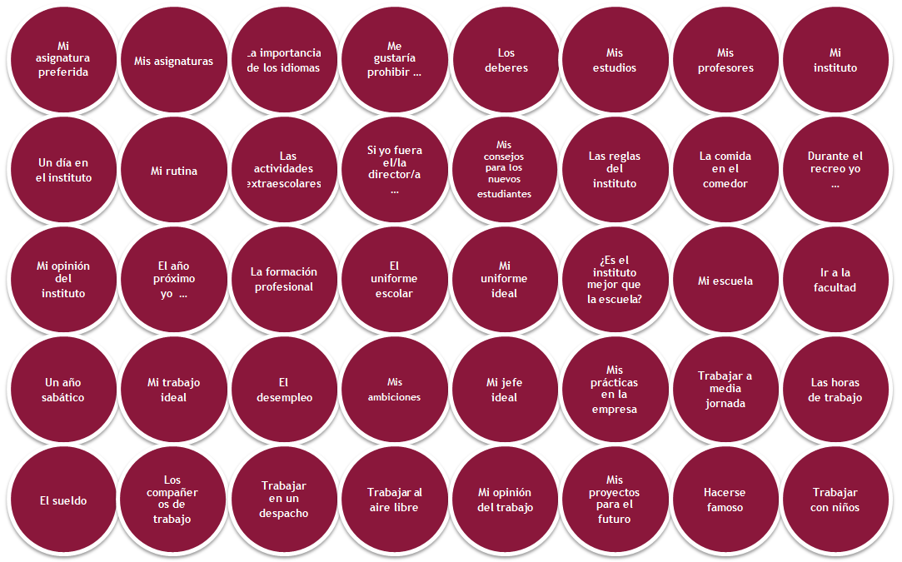

H1 - Photo cards
General conversation answers
Asking questions (pp.77-82)
A.
- ¿Qué prefiere usted?
- ¿Y usted?
- ¿Le gusta su ciudad?
- ¿Cuál es su opinión sobre los ordenadores portátiles en clase?
- ¿Qué piensa usted?

B.
- ¿Quién es su mejor amigo?
- ¿A qué fiesta le gustaría asistir?
- ¿Ha visto usted alguna película española recientemente?
- ¿Qué va a hacer usted?
- ¿Qué haría usted?

C.
Español | Inglés
Dónde | Where
Cuándo | When
Cuánto/ Cuánta/ Cuántos/ Cuántas | How much / how many
Por qué | Why
Cuál/Cuáles | Which / what
A qué hora | At what time
Quién/Quiénes | Who
Cómo | How
Acaso … | Is it that … (introduces a question)
Qué … | What …

Assessment grids: school (p.90)

adjectives  | adverbs | connectives | subordinate clauses
opinions | justifications | comparatives | superlatives
pronouns | negatives | present tense (‘yo’ form) | present tense (form other than ‘yo’)
past | future | compound tense | modal verbs

Assessment grids: family (p.92)

adjectives | adverbs | connectives | subordinate clauses
opinions | justifications | comparatives | superlatives
pronouns | negatives | present tense (‘yo’ form) | present tense (form other than ‘yo’)
past | future | compound tense | modal verbs

Rearranged sentences with translations (p.93 ex.B)

  - Mis padres, que están casados, son normalmente bastante simpáticos y amables.
My parents, who are married, are normally quite nice and kind.

  - Mi hermano, con quien yo a menudo me peleo, se llama Mathis.
My brother, with whom I often argue, is called Mathis.

  - Él sale con su novia, Millie, desde hace tres años.
He has been going out with his girlfriend, Millie, for three years.

  - Mi padre, que es de las islas Mauricio, tiene el pelo negro y corto.
My father, who comes from Mauritius, has short, black hair.

  - Mi padre es mucho más grande que mi madre, que es pequeña.
My father is a lot taller than my mother who is petite.

H1 - Photo cards
Revision

Teaching notes
In this section of the pack, you will find resources to help students to revise before the speaking exam. Answers are provided at the end of the revision section, on p.112.

Role-play revision
- Mind-map template

This blank template can be copied and used multiple times to revise role-play language on any topic.

Photo card revision
        - Word sort

This worksheet contains key words and phrases to be categorised to help describe any photo. The headings also allow students to add their own vocabulary ideas.
        - Inference grids

Each inference grid has a photo at its centre and is designed to generate vocabulary and ideas as a stimulus for speaking. Four grids are provided on the topics of mobile phones, films, festivals and relationships. However, the grids are easily adaptable to other topics – simply replace the photo with one of your choice.

General conversation revision
- Pass the parcel speaking activity

Cut up the questions provided on one or more of the themes. Each page of questions relates to one theme (la identidad y la cultura; las cuestiones locales, nacionales e internacionales; los estudios y el trabajo).
Fold up each question and put them into a sealable sandwich/freezer bag, writing the theme on the bag. Students sit in a circle or in rows and pass the bag of questions along, while you play some music.
Pause the music at random intervals. When the music stops, the student holding the bag picks out a question paper, reads out the question and answers it.
The question paper is then refolded and put back into the bag. Restart the music and the game. Try to ensure that all students have a turn!

Mind-map template
Use this mind-map template to revise for any role-play topic.

- Write the topic in the centre of the mind map.
- Note useful opinions, nouns and adjectives, verbs and questions for the topic.
- Try to predict what you could be asked for the unprepared question.
- Compare and share your ideas with a partner or small group.

Opinions |  | Topic |  | Nouns and adjectives
Verbs |  | ! |  | Questions

hemes

Word sort
- Categorise the words in the box below under the headings provided.
- There are four words for each category.
- Then add more of your own ideas to each category.

Introducing the photo | Where in the photo | People
Physical descriptions | Character/mood | Verbs
Geographical locations | Location details | Describing the location
Opinions | Conjectures | Reasons
en la ciudad / cálido / una mujer / en el exterior/ andar / aislado / en la montaña a la izquierda/ podemos ver / ya que / a causa de / hablar / en una habitación
delgado / una niña / animado / cansado / frío / en la calle / en la foto hay que yo sepa / yo diría que / podemos suponer que / en la playa
yo pienso que / quizás / pues / porque / me parece que / un hombre / contento divertirse / pelo / sonreír / detrás de / tímido / delante
en la imagen vemos/ yo creo que / puedo ver / en el campo / en el interior
a la derecha / triste / de estatura media / un niño / parece que / ojos

Inference grid – mobile phones
3. Write statements or give opinions which can be inferred from the picture.
2. Write phrases or expressions to describe the scene.
1. Label the photo with nouns and verbs.

© Jsellger2 , 2014, flic.kr/p/npoYx2

Inference grid – films

3. Write statements or give opinions which can be inferred from the picture.
2. Write phrases or expressions to describe the scene.
1. Label the photo with nouns and verbs.
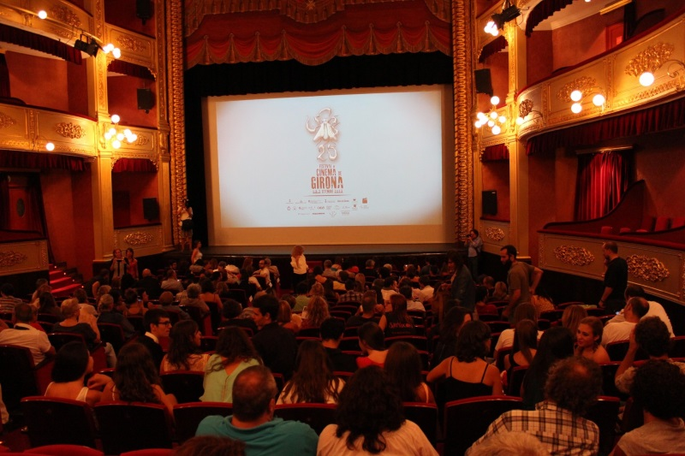

Inference grid – festivals

3. Write statements or give opinions which can be inferred from the picture.
2. Write phrases or expressions to describe the scene.
1. Label the photo with nouns and verbs.

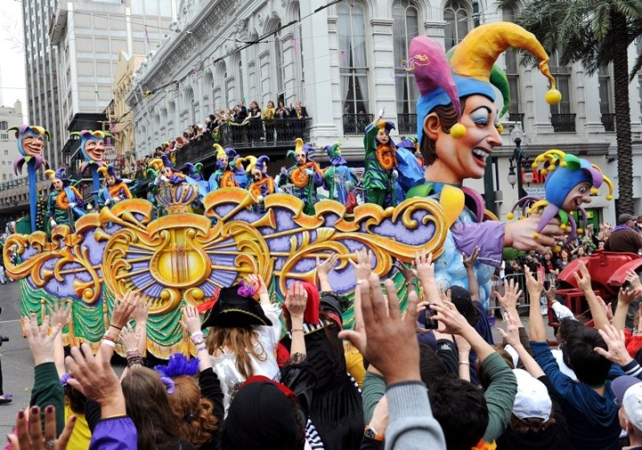
© New Orleans Celebrates Mardi Gras/ Credit: Cheryl Gerber / Getty Images News / Getty Images/ Universal Images Group / Copyright © Cheryl Gerber / For Education Use Only. This and millions of other educational images are available through Britannica Image Quest. For a free trial, please visit www.britannica.co.uk/trial

Inference grid – relationships

3. Write statements or give opinions which can be inferred from the picture.
2. Write phrases or expressions to describe the scene.
1. Label the photo with nouns and verbs.
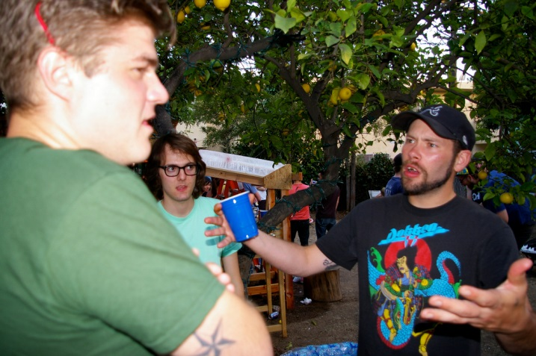

© Frederick Dennstedt, 2008, flic.kr/p/4V3iV6

La identidad y la cultura
Describe a tu familia. | ¿Quién es tu mejor amigo/amiga?
¿Te llevas bien con tu familia? ¿Por qué (no)? | ¿Te gustaría casarte / tener hijos en el futuro?
¿Cuánto tiempo pasas en Internet cada semana? | ¿Esta prohibido utilizar el móvil en tu instituto?
¿Serías capaz de pasar una semana sin acceso a Internet? | ¿Qué piensas de los coches autónomos?
¿Cuál es tu deporte preferido? | ¿Qué hiciste el fin de semana pasado? ¿Cómo fue?
¿Tienes suficiente tiempo libre? ¿Por qué (no)? | ¿Qué hobbies tenías cuando eras más joven?
Describe una fiesta española. | ¿Es importante que España celebre su cultura? ¿Por qué?
¿A qué fiesta española / hispana te gustaría asistir? | ¿Piensas que las fiestas españolas son mejores que las fiestas británicas? ¿Por qué (no)?

Las cuestiones locales, nacionales e internacionales
¿Desde cuándo vives en tu pueblo / ciudad? | ¿Cuáles son las ventajas / desventajas de tu pueblo / ciudad?
¿Qué hiciste en tu ciudad el fin de semana pasado? ¿Con quién? ¿Cómo fue? | ¿Qué pueden ver / visitar los turistas en tu región?
¿Cuáles son los problemas en tu región? | ¿Qué piensas de los periódicos de calle como The Big Issue?
¿Organiza tu instituto eventos para recolectar dinero para asociaciones benéficas? | Si tú fueras el alcalde, ¿qué harías para mejorar tu ciudad / pueblo?
¿Qué piensas del cambio climático? | ¿Te interesa la política? ¿Por qué (no)?
Si tú fueras el Primer Ministro, ¿qué harías para mejorar la situacion mundial? | ¿Deberían los países ricos ayudar a los países en desarrollo?
¿Prefieres (preferirías) pasar las vacaciones en Gran Bretaña o en el extranjero? ¿Por qué? | ¿Cuáles son las ventajas y desventajas de las vacaciones en familia?
¿Cómo serían tus vacaciones ideales? | ¿Cómo te gustaba pasar las vacaciones cuando eras más joven?

Los estudios y el trabajo
Háblame de las asignaturas en tu instituto. | ¿Por qué es importante aprender lenguas extranjeras?
¿Hay alguna asignatura que te gustaría prohibir? ¿Por qué? | ¿Piensas que los deberes son necesarios? ¿Por qué?
Describe un día típico en tu instituto. | ¿Qué haces como actividad extraescolar?
Si fueras el director / la directora de tu instituto, ¿qué harías para mejorarlo? | Háblame de tu uniforme escolar.
¿Cuáles son tus proyectos para el año próximo? | ¿En qué aspectos es la escuela diferente al instituto?
¿Crees que los jóvenes de 16 años deberían poder salir del instituto para buscar trabajo? ¿Por qué (no)? | ¿Cuáles son las ventajas y desventajas de un año sabático antes de continuar los estudios?
¿Prefieres trabajar en equipo o solo? ¿Por qué? | ¿Hay un trabajo que no harías? ¿Por qué?
¿Cuál era tu trabajo ideal cuando eras pequeño? ¿Por qué? | ¿Cuáles son los aspectos más importantes para ti con relación al trabajo?

H1 - Photo cards
Revision answers

Word sort (p.104)

Introducing the photo | Where in the photo | People
podemos ver (a)  en la foto hay  en la imagen vemos (a)  puedo ver | a la derecha  delante  detrás  a la izquierda | una niña  una mujer  un niño  un hombre
Physical descriptions | Character/mood | Verbs
de estatura media  delgado  ojos  pelo | cansado  contento  tímido  triste | andar  hablar  divertirse  sonreír
Geographical locations | Location details | Describing the location
en la montaña  en la ciudad  en la playa  en el campo | en el interior  en el exterior  en una habitación  en la calle | cálido  animado  frío  aislado
Opinions | Conjectures | Reasons
yo pienso que  me parece que  yo creo que  parece que | que yo sepa  yo diría que  podemos suponer que  quizás | ya que  a causa de  pues  porque

